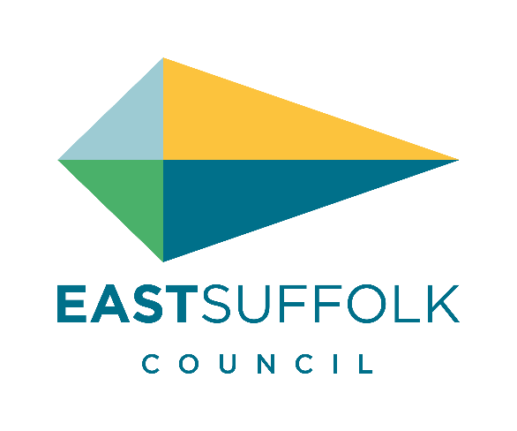 | Job Title: | Procurement Business Partner
 | Service Area: | Operations
 | Team: | Procurement
 | Salary: | Band 5 – Band 6 (SCP 18 to 27)

Job Description

Main Purpose of Job:

To deliver procurement exercises that meets the authority’s requirements and manages the resultant agreements in a way that achieves:

- Value for money
- Reduced process costs
- Acceptable levels of risk
- Increased uptake from local and Smaller/Medium Enterprises
- Commercial opportunities to create new revenue streams
- Robust and compliant procurements
- Maximum social value for the community
Providing procurement expertise to the authority including, but not exclusive to:
- Education on why to procure (and how)
- Providing a mix of appropriate routes to market
- Ensuring compliance with all relevant regulations
- Identifying risks, issues, barriers and opportunities
- Contract and performance management for assigned areas
Definition of Procurement:

The action of acquiring goods, work or services including the design of approach, specifying the requirement, engaging suppliers, managing the purchasing process, managing the contract, and disposals
Our Values:
You will be expected to work in line with our values which are:

Proud - Believing in who we are, what we do and where we live
Dynamic - Transforming the future with you in mind
Truthful - Honest and clear in all we do
Good Value - Delivering outstanding services, smartly & economically
United - Whoever we work with, we work as one team

Key Responsibilities:
- Working with service areas to create a forward looking plan to deliver procurement activity in ways that deliver value, increase efficiency and effectiveness and are attractive to the market and ensures anticipated value is delivered.
- Ongoing management and variation of departmental procurement plans to take advantage of changes in technology, policy, guidance and working practices.
- Establishing and developing a relationship with key stakeholders within the Council and through the supply chain in order to deliver the procurement plan(s).
- Ensuring that all spending within the authority is compliant with Public Procurement Regulations.
- To work with service areas to provide feedback on key contracts and manage re-procurement in a way that best supports the needs of the authority.
Additional Responsibilities:
- Maintaining the corporate Contract Register and Local Government Transparency Agenda and procurement/contract performance information for assigned areas.
- Analysing spend data to support officers to make informed, commercial decisions about purchasing.
- Ensuring the authority delivers on sustainability and Social Value aspirations through procurement exercises and contract management.
- Provide opportunities for, and engage with Small/Medium Enterprises and the local supply chain.
- Identifying and exploiting commercial opportunities allowing revenue generating activity for the authority.
- To work with internal and external bodies, from all sectors (public, private and third sector) on collaborative procurement.
- Responsible for management of procurement documentation and processes.
- Assist in developing best in class procurement strategies and processes in line with applicable external guidance (e.g. Local Government, UK Public Sector, Chartered Institute of Procurement and Supply) and passing these onto to service areas.
- To undertake such other duties as may reasonably be required compatible with and/or arising from those listed above.
- To promote and adhere to the workplace values of our organisation.

Line Manager: Procurement and Commercial Manager
Responsible for: N/A

Political Restriction:
This post is politically restricted under the Local Government and Housing Act 1989 and postholders are prohibited from seeking public election, holding political office, writing or speaking publicly on matters of political controversy.

Note: This is a description of the job as it is constituted at (January 2023) but, as the organisation develops, it may be necessary to vary the duties and responsibilities from time to time. It is the practice of the Council to periodically review Job Descriptions to ensure that they relate to the job as being performed or to incorporate whatever changes may be necessary. It is the Council’s aim to reach agreement to such reasonable changes with the postholder but if agreement is not possible the Council reserves the right to insist on changes to the Job Description after consultation with the postholder.

Person Specification
 | Essential | Desirable
Knowledge and Experience: | Band 5 requirements:  Demonstrable experience of the following:  - Managing projects  - Building, maintaining and managing effective relationships  - Organising and prioritising a varied work load  - Change management or process reengineering experience  Band 6 requirements, plus those listed above  - Professional procurement processes and contract management  - Knowledge of regulations affecting local government, the wider public sector and procurement processes  - Experience of working in a political environment  - Understanding of commercial aspects of procurement and supply. | Band 5 requirements:  - Professional procurement processes and contract management  - Knowledge of regulations affecting local government, the wider public sector and procurement processes  - Experience of working in a political environment  - Understanding of commercial aspects of procurement and supply.
Skills and Abilities: | Band 5 requirements:  - Identifying and managing key stakeholders  - Able to build rapport in order to Influence and negotiate  - Assertive communication  - Demonstrates good team work skills both within their own team and in project teams cross-functionally  - Effective organisational and time management skills to work to deadlines  - Able to propose, analyse and deliver new approaches  - Able to communicate ideas clearly through appropriate medium  - Good IT skills  Band 6 requirements, plus those listed above  - Report writing skills  - Presentation skills  - Able to lead, direct or support others.  - Commercial acumen | Band 5 requirements:  - Report writing skills  - Presentation skills  - Able to lead, direct or support others.  - Commercial acumen
Education and Training: | Band 5 requirements:  - A degree level/professional qualification in a related field or appropriate work experience  - Ability to demonstrate continuous professional development  Band 6 requirements, plus those listed above:  - Management qualification or completion of a recognised management development programme  - Working towards membership of the Chartered Institute of Procurement and Supply | Band 5 requirements:  - Management qualification or completion of a recognised management development programme  - Working towards membership of the Chartered Institute of Procurement and Supply
Other Requirements: | - Knowledge of Council services  - Flexible approach to work  - Promote a positive communication across the organisation, encourage constructive relationships and develop staff feedback methods | - A full clean driving licence

