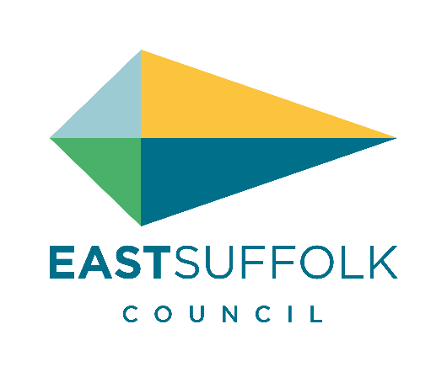 | Job Title: | Funding Officer
 | Service Area: | Economic Development and Regeneration
 | Team: | Funding Team
 | Salary: | Band 6 (SCP 24 to 27)

Job Description

Main Purpose of Job:
To work as part of East Suffolk Council’s Funding Team to collectively provide a comprehensive funding support service for the Economic Development & Regeneration (ED&R) Team. The role will also provide support the Council’s Communities Team and other service areas within the Council in applying for, accessing and managing external funding alongside managing community and business grant programmes.

To offer an efficient and comprehensive funding advice and signposting service to businesses, communities and groups across East Suffolk. In achieving this, to utilise external assistance where possible.

To establish, coordinate and administer Council-run grant funding programmes, including but not limited to the Council’s Enabling Communities Programme, Community Partnership budgets, and Sizewell C grant programmes.

Our Values:
You will be expected to work in line with our values which are:
Proud - Believing in who we are, what we do and where we live
Dynamic - Transforming the future with you in mind
Truthful - Honest and clear in all we do
Good Value - Delivering outstanding services, smartly & economically
United - Whoever we work with, we work as one team

Key Responsibilities:
- To assist the Funding Manager to maximise the opportunity for leveraging in external funding for projects and services, including support for project development, bid / application writing, with a priority focus upon economic development and regeneration projects and programmes.

- To ensure that the ED&R Team / other Council services are fully briefed about external funding opportunities and that projects and services are appropriately funded from these resources.

- To work with the Economic Development & Regeneration Team to manage and administer grants programmes including Sizewell C and other priority funding programmes, including undertaking grant assessment / due diligence and application processes, to ensure equality of provision and to maximize the impact of funding.

- To work with the Communities Team to manage and administer the Councils eight Community Partnership budgets,Community Partnership Board budget, Enabling Communities Grant Programme, and other priority funding programmes, including undertaking grant assessment / due diligence and application processes, to ensure equality of provision and to maximize the impact of funding.

- To advise on eligibility conditions and implementation criteria for identified sources of external funding and to provide advice and administrative support regarding funding claims.

- To ensure that grant-funded projects fulfil the required criteria, monitoring project delivery during the project lifecycle and keeping all necessary records.

- To signpost businesses, communities and groups across East Suffolk to support agencies providing funding advice, or where appropriate provide funding advice, which helps them source funding to develop and deliver projects.

- To promote the services of the funding team and opportunities around external funding to different audiences both internal and external.

- To undertake other duties compatible with and or arising from the duties specified above.

- To promote and adhere to the workplace values of our organisations.

Line Manager: ED&R Funding Manager
Responsible for: N/A

Political Restriction:
This post is not politically restricted.

Note: This is a description of the job as it is constituted at (March 2023) but, as the organisation develops, it may be necessary to vary the duties and responsibilities from time to time. It is the practice of the Council to periodically review Job Descriptions to ensure that they relate to the job as being performed or to incorporate whatever changes may be necessary. It is the Council’s aim to reach agreement to such reasonable changes with the postholder but if agreement is not possible the Council reserves the right to insist on changes to the Job Description after consultation with the postholder.
Person Specification
 | Essential | Desirable
Knowledge and Experience: | - Experience in the development of external funding applications related to Economic Development, Regeneration and Community projects.  - Knowledge of relevant funding organisations / sources and application procedures relevant to local government.  - Experience in coordinating and administrating grant funding programmes, including undertaking due diligence and monitoring  - Knowledge of key national / regional / local strategies and policies relevant to economic development and regeneration | - Experience of research and monitoring.  - Experience of working with Elected Members.  - Experience of working with businesses and/or local communities.  - Familiarity with the preparation of budgets and financial profiles for projects.  - Experience in project management of grant funded projects  - Experience in the preparation of Council / formal reports.
Skills and Abilities: | - Good communication skills and the ability to communicate effectively with a wide variety of internal and external partners.  - Good research skills  - Strong numeracy and data handling skills.  - Excellent interpersonal, networking and relationship management skills.  - Ability to think creatively and innovate.  - Ability to motivate others and work with minimal supervision as well as part of a team.  - Analytical and detailed approach.
Education and Training: | - Educated to degree level or equivalent. | - Experience in financial services, particularly accounting/auditing of grant-aided projects.
Other Requirements: | - A commitment to own development and to supporting training and development initiatives.  - Necessary to work within data protection and confidentiality requirements.  - A commitment to equality of opportunity, diversity and corporate working.  - Must be mobile / have access to a car to attend business meetings at other sites / locations within the district on a regular basis.

