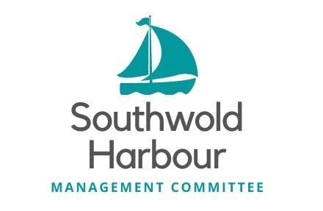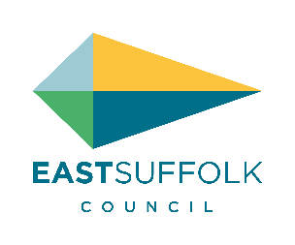
APPLICATION TO BE A CO-OPTED MEMBER OF THE
SOUTHWOLD HARBOUR MANAGEMENT COMMITTEE

Full Name
Address
Email Address
Contact Numbers

The skills audit set out below takes into account the key tasks and priorities of the HMC:
- To review and finalise the Schedule of Assets for Southwold Harbour (and review annually)
- To draw up an initial / five year business plan for Southwold Harbour (and then implement, with an annual and five year review)
- To draw up the proposed budget for Southwold Harbour annually (and then to report on performance against budget every 6 months)
- To prepare an annual report for Southwold Harbour every year
In addition, in line with the MoU and Terms of Reference, the following additional tasks will also be key tasks and priorities for the HMC:
- To consult with the Stakeholder Advisory Group and other stakeholder as appropriate
- To consider and progress an application for a Harbour Revision Order to modernise the statutory provisions applying to Southwold Harbour (including placing the HMC and Advisory Group on a statutory footing)
- In designing these long-term improvements, by applying for a Harbour Revision Order or otherwise:
  - specific safeguards should, subject to legal advice and the requirements of stakeholders, be included to protect income from the Harbour and preserve the Harbour in the ownership of the Council; and
  - the HMC should consider whether any appropriate additional powers should be sought, including powers of general direction and / or to carry out or fund works to the Blyth estuary, outside the Harbour, for the protection of the Harbour.

Key Skills
Taking into account the above tasks, it is considered that the key skills required on the HMC include:
- Risk Management and Mitigation (particular focus on Coastal defence, flood protection and mitigation (including knowledge of the Environment Agency) climate change, health and safety and marine engineering)
- Knowledge of and management of ports / harbours
- Business Planning / Financial (including securing grant or other funding)/ organisational / strategic planning and management.
- Knowledge of local stakeholders including the local community (e.g. local authorities, residents, businesses, commercial users, leisure users, caravan site owners, visitors, Blyth estuary)
- Management / development of property / facilities (and in particular caravan site operation and tourism)
- Communications, marketing and consultation

Other Skills
Other skills that are considered important and would be useful to have on the HMC include:
- Local industrial, commercial or financial matters
- Management of marine leisure activities
- Personnel management
- Environmental matters
- Legal
- Shipping and other forms of transport
- General maritime or other nautical experience
- Any other skills and abilities considered from time to time by the HMC to be relevant to the discharge by the HMC of its functions
In addition, when undertaking HMC business, all HMC members will be expected to actively seek to resolve challenges presented to the HMC through working together in a positive and constructive manner. As such team working and problem solving are important skills for all HMC members.

How you meet the criteria
Please state in the space below why you feel that you would be a suitable person to sit on the HMC, together with your qualifications, the experience you would bring and which of the key skills you meet:

Other details
Please state below whether you have any potential conflicts of interest.

Are you related to any Councillors or employees of East Suffolk Council?

Have you ever been convicted or a criminal offence, other than a spent conviction under the Rehabilitation of Offenders Act 1974? If yes, please give further details.

Signed:

Dated:

Completed application forms should be returned by 17.00 on 21 September 2026

