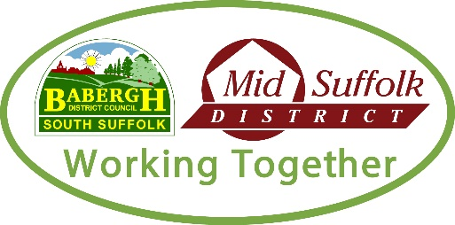

Supporting Statement
Once complete, please upload this form when completing your online application.

Candidate number (BMSDC use only):

Vacancy job title:

We offer a guaranteed interview for all candidates who have a disability and meet the minimum criteria in their application. If you have a disability, please tick here to confirm you would you like to be offered a guaranteed interview. |  | ☐
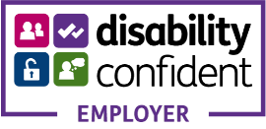 | If you require any adjustments to this application process due to a disability, then please email hrsupportteam@baberghmidsuffolk.gov.uk

My Supporting Information
Please go to the advert text for instructions on what to include in your statement. For further guidance on our application process please click on this hyperlink to How to complete your Application Form

