Pay and Progression Scheme for CYP Social Workers - Updated June 2022
Social Work Salary Ranges
The salary ranges offered for each post fall within the existing SCC grade ranges which have been assigned to the Social Work posts through the job evaluation framework.

They provide a commencing salary within each grade which is above the lower increments of the grade range and enable annual progression through the full incremental salary scale to the top of the grade.

Grade Ranges Post | Grade for post | Starting spinal column point | Maximum spinal column point
Newly Qualified Social Worker | Fixed salary - grade 5 scp 16*
Social Worker | 5 | 18 | 21
Senior Social Worker | 6 | 22 | 26
Consultant Social Worker | 6 | 24 | 26
IRO’s | 7 | 29 | 32
Practice Manager | 7 | 30 | 32
Service Manager | 8 | 33 | 38

- Plus, additional payments that are currently made which include:
  - Welcome payment of £500 for Newly Qualified Social Workers
  - Option for a welcome loan of £2000

Following the end of the incremental pay freeze in 2020 and reintroduction of PDR related incremental increases across all single status roles, the wider SCC PDR framework now supersedes the 2015 CYP social worker pay progression scheme. The guidance on PDRs and incremental progression is available on AskHR. https://askhr.suffolk.gov.uk/corporate/

For newly qualified Social Workers, following their Assessed and Supported Year in Employment (ASYE) and successful completion and sign-off of their portfolio by 31st October, they will be moved up from scp 16 to the Social Worker starting point, scp 18 (backdated to the date of their successful portfolio submission). They will also be eligible for a further PDR increment in the following April, subject to the corporate performance criteria being achieved.

Social Worker Retention Payment and Annual Leave
In recognition of the competition in terms of pay and reward offered by neighbouring authorities and the impact on recruitment and retention of social workers, from 1st April 2020 retention payments (annual figures, pro-rata for part time staff) will be applied to the following roles.

Role | Retention payment
Newly Qualified Social Worker | £1500 per annum
Social Worker | £4000 per annum
Senior Social Worker (at scp 22) | £4000 per annum
Senior Social Worker (at scp 23 or above) | £3500 per annum
Consultant Social Worker | £3500 per annum

In addition, those in the above roles will have their annual leave allowance increased by 3 days per annum (pro-rata for part time staff)

Process for moving into the next role

The career pathway developed for Social Work posts enables a progression through grade levels:

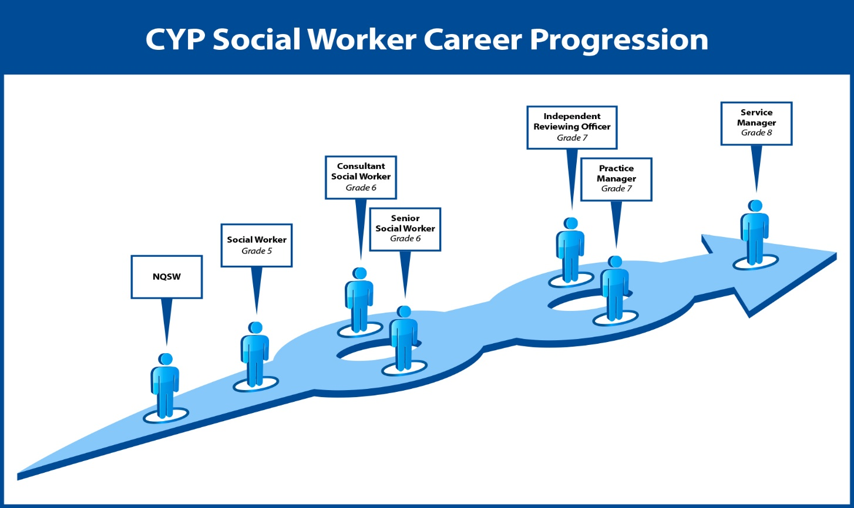
Each post has a JPP outlining the duties and responsibilities of that role, together with a person specification which identifies the essential skills, knowledge, approach and experience that must be met by the post holder. For example, to progress from SW grade 5 post to an Senior SW grade 6 post, there is a requirement of a minimum 2 years post qualifying, relevant Social Worker experience. This would be alongside an essential requirement to be able to demonstrate the breadth and depth of experience required for the role.

Progression to another role will be on the basis of a vacancy arising and will be subject to application and selection. Detailed below is the process for Social Work progression to another role;

Stage | Process
Vacancy | - There is no automatic progression into another role in this scheme other than for NQSWs to move automatically into a Social Work post  - For all other opportunities, Vacancies will be advertised via Suffolk Jobs Direct.  - Internal short-term arrangements such as secondments, by email across relevant services
Application | - For Grade 5 Social Work positions, there will be a requirement for a CV and short application  - For higher graded roles, a full statement of interest will be required
Selection | - Selection will be based on a scored interview, assessing skills, experience and competencies for the role
Outcome | - Once selection decisions have been made, those appointed will be offered the role.  - Where the successful candidate is promoted, they will be offered the role at the first spinal column point in the higher grade they are moving into  - Those unsuccessful candidates will be offered detailed feedback areas they need to develop and advice and guidance as to how they can be worked upon; for example, through job shadowing, opportunities to take on more/different responsibility, further learning or training opportunities.

Please note that within the same role type, there may on occasion be the need for flexible movement between teams, services and areas to meet service demands as determined by the Service Manager (within areas) and Head of Service (across areas). These may be informal short-term arrangements, or where longer-term opportunities arise (e.g., secondments/acting ups), may involve a selection process where this is necessary.

Appointing external candidates
For all new appointments salary offers should be equitable with what current employees are being paid within this scheme. They should be offered a salary in line with the above guidance in relation to both role-relevant experiences, assessed competence and number of years’ experience, and the Head of Service will approve these.

Exceptional circumstances – Where a new appointee is currently being paid at a higher rate than the above guidance would suggest but they have valuable skills and experience to bring, then an exceptional circumstance case can be made to the Assistant Director, via the Head of Service. This will need to include the rationale for the proposed SCP to be offered.

Team experience mix

The working aspiration is to have a social work staffing mix that roughly reflects the following ratio:

- 30% Grade 6 Senior Social Workers
- 50% Grade 5 Social Workers
- 20% NQSWs

It is recognised that this skills mix is not always achievable, so to enable teams to transition to a point where they reflect the above balance, where a fieldwork team has less than 30% of the establishment as Senior Social Workers, it may be that successful applicants for the Senior Social Worker vacancies are required to transfer into these teams, to ensure an equitable spread of experience across the service.

Exceptional Circumstances – internal staff
Where an internal member of staff has skills and experience highly valued to SCC, and you wish to make a more attractive offer to retain them, then an exceptional circumstances case can be made to the Assistant Director, via the Head of Service. This will need to include the rationale for such exception and the proposed SCP. for example, if an employee has evidently been made a more attractive offer elsewhere we are seeking to match, in order to avoid the loss of such expertise and an associated significant detriment to the team or wider service provision.

Exceptional circumstances provision cannot be applied to reward performance, which is addressed through the PDR process.

