Statement of Interest Form
Once complete, please upload this form when completing your online application.

Candidate number (SCC use only):

Important, please note: We run an anonymised recruitment process up to the point of interview. This means the hiring manager will not be provided with any personal details. Therefore, please do not include your name or any other personal details on this document or in the file name of this document.

Vacancy job title:

We are a Disability Confident Leader and will offer an interview to disabled applicants who meet the minimum/essential criteria for the role. Please confirm if you would like to apply through the Disability Confident Interview Scheme. |  | ☐
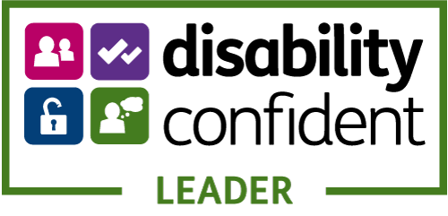 | If you require any adjustments to this application process due to a disability, then please click on this hyperlink to email recruitment@suffolk.gov.uk

We also offer a guaranteed interview for those Care Leavers who have been in our care for three months or more since the age of 14, are under the age of 25 and meet the essential criteria. Please tick here if this applies to you. | ☐

My Supporting Information
Please go to the advert text for instructions on what to include in your statement. For further guidance on our application process please click this hyperlink to visit our How to apply’ web pages.

