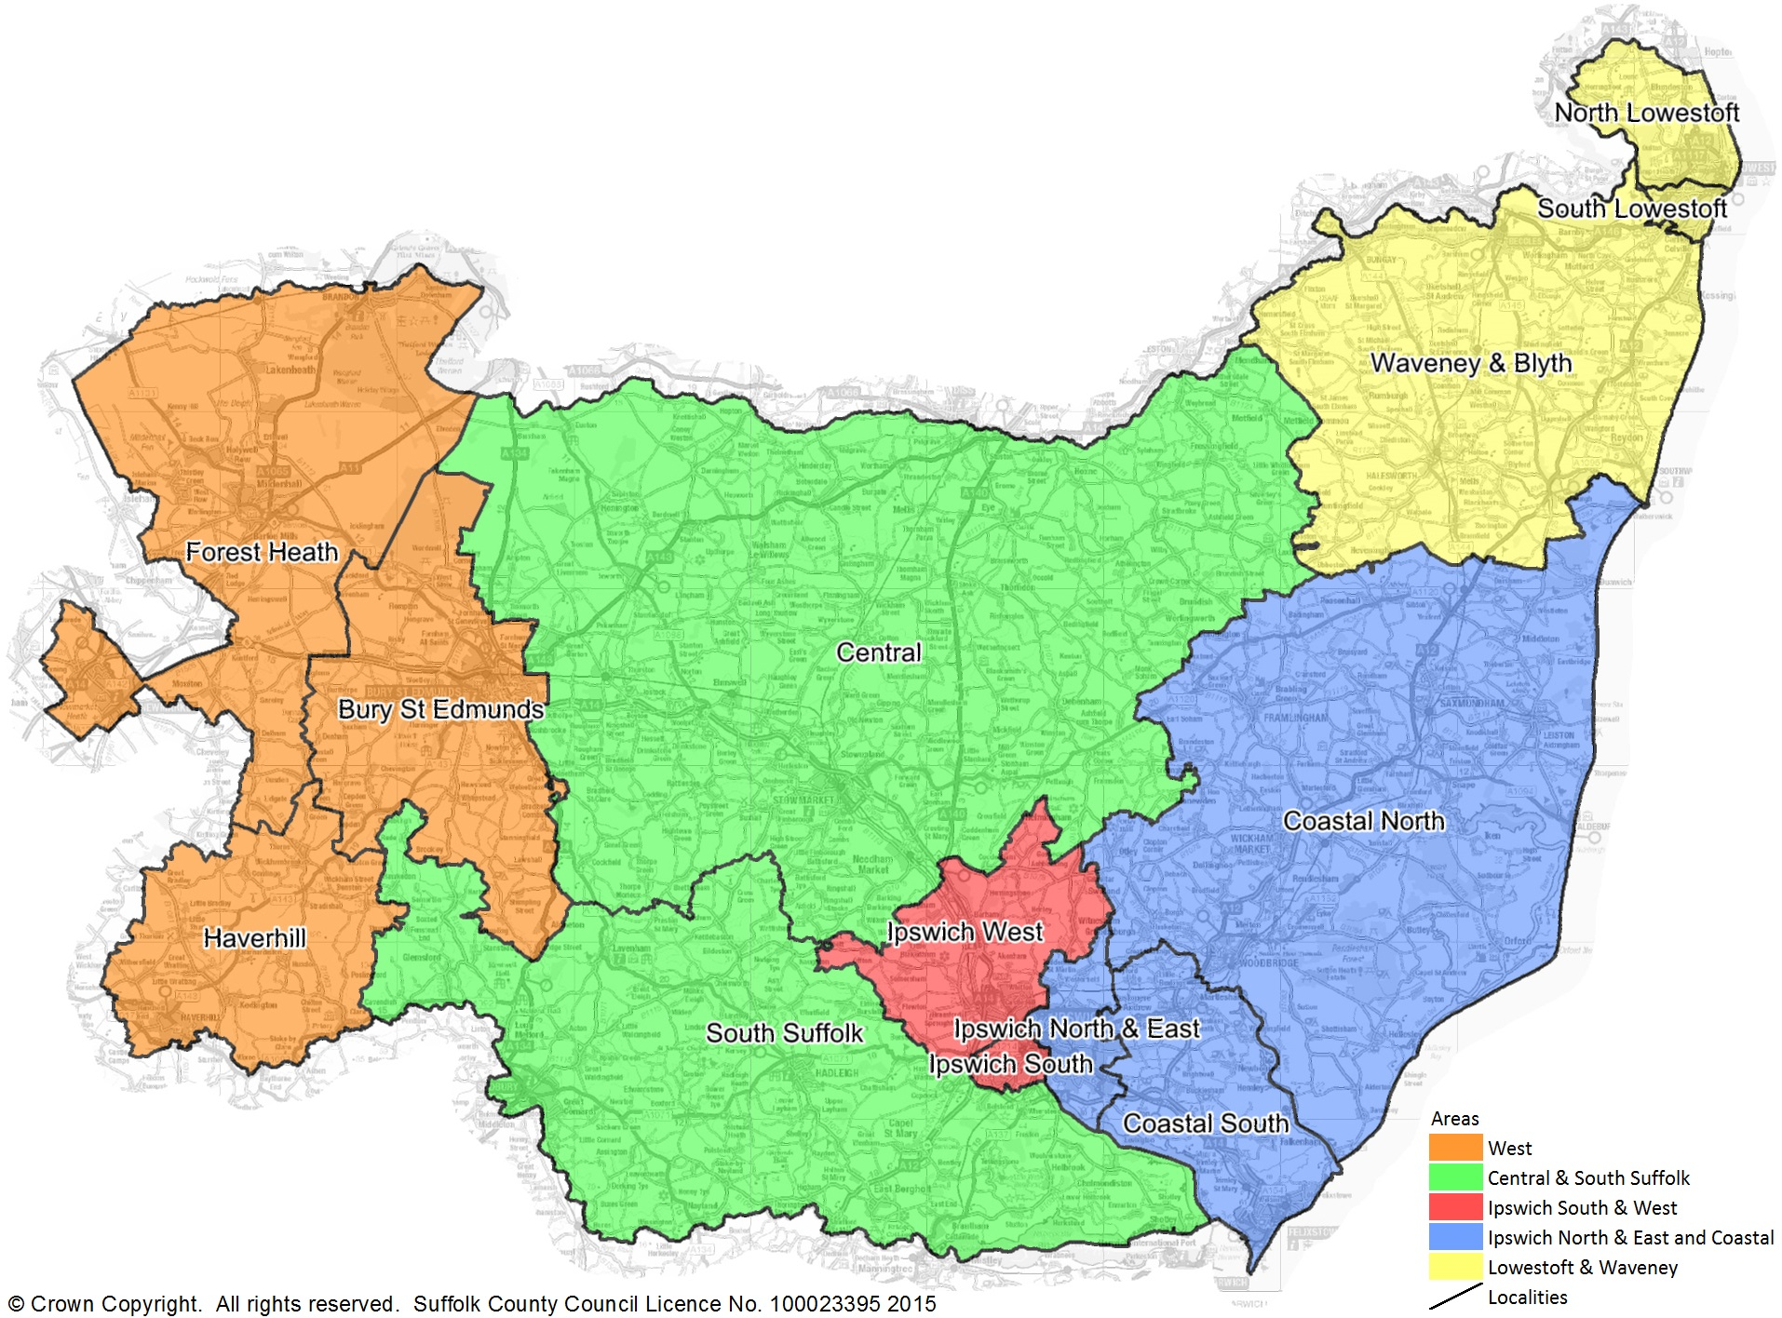

Suffolk Map - Early Help & Social Care Teams