


Job and Person Profile (JPP)

Job details
Job title | Watch Manager Policy
Job Reference | 24357
Grade and Salary | Watch Manager B – Grade 6
Service and team | Suffolk Fire and Rescue Service, Organisational Risk and Improvement, Risk & Resilience, Policy Team
Location | Endeavour House / Hybrid. There is flexibility to work from other Suffolk County Council buildings or Suffolk Fire and Rescue Service Stations.
Hours per week | 42
Status | Permanent
This role may offer the following flexible working options. | - Working compressed hours (eg a nine-day fortnight).  - Use of flexitime / time off in lieu.  - Hybrid working options, including some home working.  - Working from different Council buildings.  - Working adjusted core hours (eg starting later and finishing later or other patterns).

About us
As a modern and effective council, we understand the importance of being flexible and well-connected in the ways we work. We focus our ambitions on doing what’s right for people, our partners and our communities - both now and for the future.

That’s why, as one of the largest employers in Suffolk, we believe in empowering everyone. Through career variety and collaborative working, accessible career paths and professional development.

The support and care we offer encourages and enables you to be the best you can be. To make a meaningful impact on the world around you. To achieve a unique sense of pride in what you do, why you do it and where. Reimagine the possibilities.

Main purpose of the job
To support the development, implementation, and review of policies, procedures, and strategic documents to ensure Suffolk Fire and Rescue Service (SFRS) operates in line with legislative requirements, national guidance, and local priorities. The WM Policy will work closely with internal stakeholders and external partners to promote consistency, transparency, and continuous improvement across the service.

About the team
The Policy Team at Suffolk Fire and Rescue Service plays a vital role in shaping the strategic direction and operational consistency of the service. Working closely with senior leaders, operational teams, and external partners, the team develops, reviews, and maintains policies and procedures that ensure compliance with national frameworks, legislative requirements, and local priorities. By providing evidence-based advice and fostering a culture of continuous improvement, the team helps to enhance service delivery, support staff, and ultimately protect the safety and wellbeing of communities across Suffolk.

You will report directly to the SM Policy Manager – Risk & Resilience.
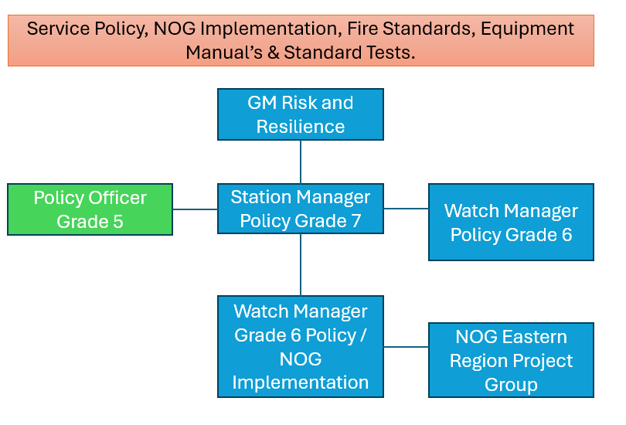

What you will be expected to deliver in the role
Day to day tasks may include:
- Provide visible leadership and management. Uphold the highest standards of appearance, bearing, confidentiality, courtesy, and professionalism, whilst ensuring the highest levels of operational readiness are maintained.
- Manage yourself taking responsibility for your own personnel development, motivation, performance, behaviour, health, safety, and general wellbeing through the application of appropriate policies and procedures.
- Provide management support to ensure the consistent day-to-day management of the department in accordance with guidance and SCC policy and service/business plans. Where relevant ensure line management of staff under your control is efficient, effective, and matched to the allocated physical and financial resources.
- Support departments to review, create and develop policies in line with national fire and rescue frameworks, local risk profiles, and legislative changes.
- Analyse and interpret government policies, regulations, and data to inform SFRS strategy and accountable owners.
- Advise on the need for completion of risk assessments and equality impact assessments, to support policy need.
- Maintain an up-to-date policy tracking system to monitor the development, review, and implementation of all service policies,
- Review draft internal policy documents, guidance notes, National Operational guidance and Fire Standards.
- Lead and support consultation exercises with staff, unions, partners, and the public.
- Monitor policy implementation and effectiveness through performance indicators and stakeholder feedback.
- Contribute to the preparation of reports, briefings, and presentations for senior management and stakeholders on progress, compliance, and any areas requiring action.
- Liaise with Suffolk County Council departments and external agencies to ensure policy alignment.
- Provide advice and guidance to managers and teams on policy interpretation and application.
- Support the Service’s response to inspections (e.g. HMICFRS), audits, and peer reviews by maintaining policy compliance evidence.
- Promote equality, diversity, and inclusion through inclusive policy design.
- Maintain the operational competence requirements of incident command level 1 (ICL1) supporting other commanders at operational incidents as part of a wider incident command structure.

Although this list provides examples of what you will be doing it is not intended to be exhaustive, and you will have personal objectives linked to our People Plans and Strategies that will be discussed and agreed with your line manager when you start.
Person Profile – what you will bring to the team

Qualifications and professional memberships

Qualifications (essential)
- Incident Command Level 1
- NFCC Supervisory Management pathway or
- Level 5 qualification (e.g. Foundation degree, higher national diploma, or equivalent experience) in a relevant subject such as public policy, public administration, business management, social sciences or fire service studies.
- NEBOSH HSE award in managing risks and risk assessment at work or equivalent in workplace risk management.
- Familiarity with or memberships of relevant fire and rescue or public policy networks (e.g. NFCC policy and reform unit forums, LGA policy groups).
- Evidence of continued professional development related to policy, governance, or public service improvement.

Qualification (desirable)
- Level 6 qualification (e.g. Bachelor’s degree) in relevant area.
- Membership of a relevant professional body (e.g. chartered institute of public finance and accountancy (CIPFA), institute of leadership and management (ILM), or chartered institute of personal and development (CIPD).
- Professional training or certification in policy development, project management, or data analysis (e.g. PRINCE2 foundation).

Values and personal qualities
- Demonstrates a passion for making a positive difference for Suffolk.
- Shares our WE ASPIRE Values and strives to lead by example in relation to these.
- A strong commitment to fairness and Equality, Diversity and Inclusion (EDI).
- Strives to continuously improve in everything they do, taking the initiative to learn and develop.
- Brings creativity into their work through innovation and openness to change.
- Collaborates well with others and offers assistance and support to colleagues.

Specialist knowledge skills and experience
- Knowledge of national fire and rescue service frameworks, including the Fire and Rescue National Framework for England, relevant legislation (e.g. Fire and Rescue Services Act 2004, Civil Contingencies Act 2004), and inspection regimes (e.g. HMICFRS).
- Experience in drafting, implementing, and reviewing policy documents within a public sector or emergency services context, ensuring legal compliance and operational relevance. (desirable)
- Strong analytical and research skills, with the ability to interpret complex information, legislative changes, and performance data to inform policy decisions.
- Excellent written and verbal communication skills, including experience preparing clear, concise reports, briefings, and policy documents for senior management and stakeholders.
- Experience engaging with a wide range of internal and external stakeholders, including senior leaders, frontline staff, local authorities, and members of the public.
- Understanding of equality, diversity, and inclusion principles and how to embed them effectively in policy development and consultation processes
- A good understanding and use of IT systems in use across SFRS.

Additional requirements
- Full UK driving licence.

If you think you have what it takes to be successful in this role, even if you don’t meet all the criteria, please apply. We’d appreciate the opportunity to consider your application.

Travel requirements
Due to the nature of this role, you will require a driving licence and access to personal transport. SFRS do have a fleet of pool cars which may be available to you, following assessment and availability.

Our Values – WE ASPIRE


At Suffolk County Council our WE ASPIRE values set out the behaviours we expect from everyone in the organisation regardless of who they are, what their role or grade is or where they work.

The values have been developed through feedback and input from employees at the council and underpin how we go about our everyday work. They define us and help us to be the best we can be.

Visit our careers pages for more information on our WE ASPIRE values.

Our Customer Commitment



In addition to our WE ASPIRE values, we also have a Customer Commitment which sets out a number of strong principles that help support high standards of customer service and care that we can all endeavour to consistently demonstrate.

For more information, view our Customer Commitment poster.

Our Core Code of Ethics
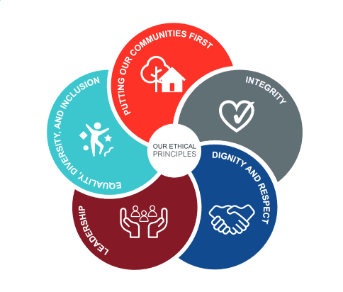
At Suffolk Fire and Rescue Service, the Core Code helps every member to act in the right way in our service to the public and towards each other. The Core Code applies to everything we do. It will help us to continue to do our jobs professionally and to the best of our ability.

Visit the NFCC Core Code of Ethics page for more information.

More information for recruitment applicants

We offer a fantastic working environment including diverse and active staff networks,
great flexible working options and many benefits, as well as the opportunity to improve the lives of Suffolk residents.

Visit the Suffolk County Council career website to learn more, including information about adjustments to recruitment processes, our interview schemes and other commitments to equality, diversity and inclusion.

