


Job and Person Profile (JPP)

Job details
Job title | Emergency Planning Officer
Job Reference | 20770
Grade and Salary | 5 - £34,434 per annum (pro rata for part time) plus JEPU standby allowance
Service and Team | Joint Emergency Planning Unit
Location | Endeavour House, Russell Road, Ipswich, Suffolk, IP1 2BX – Hybrid
Hours per week | 37
Status | Permanent
This role may offer the following flexible working options | - Working compressed hours (e.g. a nine-day fortnight)  - Use of flexitime / time off in lieu  - Hybrid working options, including some home working  - Working from different Council buildings  - Working adjusted core hours (e.g. starting later and finishing later or other patterns)

About us
As a modern and effective council, we understand the importance of being flexible and well-connected in the ways we work. We focus our ambitions on doing what’s right for people, our partners and our communities - both now and for the future.

That’s why, as one of the largest employers in Suffolk, we believe in empowering everyone. Through career variety and collaborative working, accessible career paths and professional development.

The support and care we offer encourages and enables you to be the best you can be. To make a meaningful impact on the world around you. To achieve a unique sense of pride in what you do, why you do it and where. Reimagine the possibilities.

Main purpose of the job
- The post holder will be expected to lead specific emergency preparedness related areas in one or more local authorities in support of their planning and preparation for responding to emergencies and serious disruption to normal services.
- To participate in local authority emergency response and recovery as appropriate (tactical management and liaison).
- To give professional advice to officers and elected members of the authorities to ensure the safety of the public during an emergency.
- The post will be directly line managed by a District Emergency Planning Manager.

About the team
The Joint Emergency Planning Unit was formed in 2005 between all Suffolk local authorities to provide an emergency planning and business continuity planning service. The team provide a focal point for civil emergency preparedness within Suffolk councils and provides a 24/7 out of hours duty service and initial emergency management capability. (See attached JEPU Structure chart)
What you will be expected to deliver in the role
- To support local delivery of emergency planning and business continuity in compliance with all the relevant legislation.
- To contribute to the JEPU Business Plan and the Community Risk Register for locally perceived risks.
- Development and maintenance of relevant emergency plans, policies and procedures for the authorities to comply with the Civil Contingencies Act 2004 and other relevant legislation.
- To support an authority’s local response in the event of an emergency or serious threat to public wellbeing, and provide assistance and professional advice to elected members, the Chief Executive, senior officers and communications team.
- To deliver, evaluate and review training courses that will support all plans and procedures.
- Support the preparation, execution and evaluation of exercises designed to test the effectiveness of the authorities’ emergency plans and procedures, and for implementing any remedial actions necessary.
- Support District Emergency Planning Manager in providing advice and assistance on the preparation and maintenance of effective business continuity plans and emergency procedures for the delivery of critical council services during an emergency or serious disruption to normal services
- To promote and support training to external organisations.
- To promote and support communities to encourage community resilience and business continuity.
- To support the JEPU Business Continuity Manager (BCM) in the development of effective links with local businesses that will enhance and extend business continuity awareness.
- To liaise with officers of the emergency services, public utilities, health, neighbouring authorities, voluntary organisations and such other organisations as may be necessary in order to ensure effective planning for, and management of, civil emergencies, local events and incidents.
- To undertake the lead role for specific risk areas as identified in the JEPU Organisation and Responsibilities.
- To actively promote awareness of the Suffolk Joint Emergency Planning Unit within the authorities and the wider community.
- To maintain levels of professional knowledge to ensure best practice is disseminated.
- To be prepared to work flexibly outside of normal working hours, within reason, to meet the requirements of the role.
- To provide out of hours duty cover on a rota basis (see Appendix B) for the purposes of receiving and disseminating warnings and information from the emergency services or other organisations relating to actual or potential emergencies; and to undertake such duties in connection with an emergency (or serious threat thereof) that occurs during these periods as may be necessary to assist the local authority to resolve it.
- Undertake any other duties of a similar nature appropriate to the grade as directed by the Head of Emergency Planning (HEP).

Person Profile – what you will bring to the team

Qualifications and Professional memberships
- Relevant qualification at RQF level 3, or equivalent level of knowledge or experience.
- Holding or working towards a full professional qualification with relevant experience [Desirable].
- Membership of the Emergency Planning Society or Business Continuity Institute or similar relevant professional body. [Desirable].

Values and personal qualities
- Demonstrates a passion for making a positive difference for Suffolk.
- Shares our WE ASPIRE Values and strives to lead by example in relation to these.
- A strong commitment to fairness and Equality, Diversity and Inclusion (EDI).
- Strives to continuously improve in everything they do, taking the initiative to learn and develop.
- Brings creativity into their work through innovation and openness to change.
- Collaborates well with others and offers assistance and support to colleagues.

Specialist knowledge skills and experience
- General awareness of fundamental concepts and theories in emergency management.
- General awareness of the structures in place in local government.
- General awareness of emergency planning, business continuity, management, business planning or risk management.
- Experience of undertaking project work.
- Willing to learn from those with knowledge and experience of working in Emergency Management.
- Able to manage complex workload to meet deadlines.
- Able to work effectively without access to regular supervision.
- Able to develop and maintain good relationships with current/potential customers and partner agencies.
- Ability to advise and assist managers and others on policy and procedures, clearly, patiently and succinctly.
- Working with elected members and senior officers providing advice on policy matters.
- Successfully managing and delivering projects within a complex organisation.
- Designing and delivering multi-media training events and/or briefings for a range of participants.
- Preparing reports and/or research papers for meetings or management decision making.
- Good working knowledge of MS Office suite.
- Good report writing skills.
- Good knowledge of the legislative and regulatory requirements of local authorities relevant to emergency planning, risk management and business continuity planning [Desirable].
- Previous experience of local government, its’ range of services and key current developments [Desirable].
- Experience of preparing, exercising, reviewing and revising emergency plans [Desirable].
- Experience of successfully managing an emergency or crisis [Desirable].

Additional requirements
- A full, clean UK driving licence is required.
- Police vetting to NPPV2 will be required for this role.
- Frequent travel across the county to attend meetings or respond during emergencies is required.

If you think you have what it takes to be successful in this role, even if you don’t meet all the criteria, please apply. We’d appreciate the opportunity to consider your application.

Travel requirements
You will need to travel, so you must either hold a full, current driving licence and have access to personal transport or meet the mobility requirements of the role through other reasonable and suitable means.

Our values – WE ASPIRE



At Suffolk County Council our WE ASPIRE values set out the behaviours we expect from everyone in the organisation regardless of who they are, what their role or grade is or where they work.

The values have been developed through feedback and input from employees at the council and underpin how we go about our everyday work. They define us and help us to be the best we can be.

Visit our careers pages for more information on our WE ASPIRE values.

Our Customer Commitment



In addition to our WE ASPIRE values, we also have a Customer Commitment which sets out a number of strong principles that help support high standards of customer service and care that we can all endeavour to consistently demonstrate.

For more information, view our Customer Commitment poster.

More information for recruitment applicants

We offer a fantastic working environment including diverse and active staff networks,
great flexible working options and many benefits, as well as the opportunity to improve the lives of Suffolk residents.

Visit the Suffolk County Council career website to learn more, including information about adjustments to recruitment processes, our interview schemes and other commitments to equality, diversity and inclusion.

Suffolk Joint Emergency Planning Unit - Structure Chart

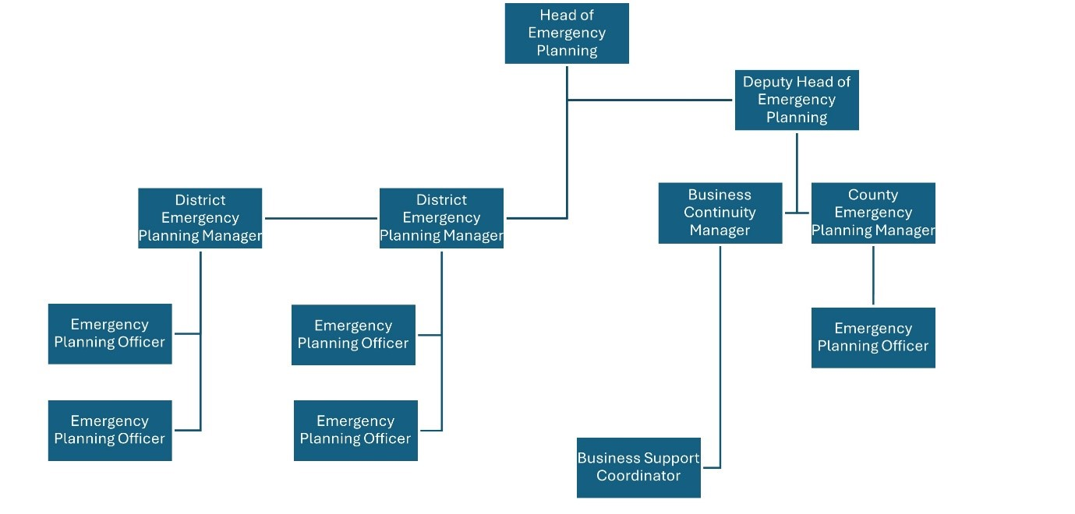

Out of Hours Rota

The postholder will be required to undertake duties as the out-of-hours duty Emergency Planning Duty Officer (EPDO) on a shared rota basis, for which an on-call allowance shall be paid. Additional work conducted as part of response to an incident will normally be remunerated by provision of Time Off In Lieu (TOIL). However, if the incident response is protracted or the provision of TOIL is impracticable, an overtime payment may be made upon application, subject to authorisation by the Head of Emergency Planning.

The rota will require the post holder normally to be continuously on call for seven days from Midday Friday to Midday the following Friday, approximately once every eight weeks. Special arrangements may occasionally apply in the event of long term sickness or other absences, requiring more frequent duty, but every effort will be made to keep such occasions to the absolute minimum.

During a period of on-call duty as the EPDO, the postholder will be required at all times to be permanently and immediately contactable by the representatives of category 1 or 2 responders (iaw Civil Contingencies Act(2004)), or if not able to be so for any reason, shall be responsible for arranging a stand-in substitute for the necessary period from amongst the other persons on the rota.

The post holder will be required at all times whilst on call to maintain themselves in a fit state to perform such duty as may be required of them, including the requirement to drive, supervise others or operate machinery. The postholder will be required, at the end of each period as EPDO, to carry out a proper handover to the succeeding EPDO to ensure details of existing events or incidents in progress are properly passed on.

The scope of the duties will be dependent upon the nature of the emergency, but the EPDO will be expected to provide whatever advice and guidance is required to the relevant officers in the local authority either by phone, radio or in person as dictated by the situation.

