


Job and Person Profile (JPP)

Job details
Job title | Deputy Chief Fire Officer
Job Reference | 16441
Grade and Salary | £121,662 per annum (exclusive of flexi duty allowance of £3,836)
Service and Team | Fire and Public Safety, Suffolk Fire and Rescue Service
Location | Endeavour House, Russell Road, Ipswich, Suffolk, IP1 2BX
Hours per week | 42
Status | Permanent
This role may offer the following flexible working options | - Working part time hours (eg different hours/days to those advertised)  - Job sharing  - Working compressed hours (eg a nine-day fortnight)  - Term time working (including partial term-time working)  - Use of flexitime / time off in lieu  - Hybrid working options, including some home working  - Working from different Council buildings  - Working adjusted core hours (eg starting later and finishing later or other patterns)

About us
As a modern and effective council, we understand the importance of being flexible and well-connected in the ways we work. We focus our ambitions on doing what’s right for people, our partners and our communities - both now and for the future.

That’s why, as one of the largest employers in Suffolk, we believe in empowering everyone. Through career variety and collaborative working, accessible career paths and professional development.

The support and care we offer encourages and enables you to be the best you can be. To make a meaningful impact on the world around you. To achieve a unique sense of pride in what you do, why you do it and where. Reimagine the possibilities.

Main purpose of the job

- As a Leader, you will be expected to promote the county council’s vision, objectives and priorities effectively to staff, partners, and the public and inspire others by role modelling our organisational values at all times.
- You will promote a culture of fostering innovation, value for money and outcome-based customer focus.
- To assist, develop and deliver a strategic approach to the Fire and Rescue Service on behalf of the Authority in line with the National Framework, the Fire & Rescue Services Act and local priorities with a key focus on the provision of high-quality services to the communities of Suffolk

- To shape the strategic direction of people management and workforce planning ensuring effective working relationships with the representative bodies, area managers and key people across the service

- Role model Equality Diversity and Inclusion (EDI) by supporting the EDI vision and encourage colleagues to reflect the same approach

- To lead on Fire & Rescue Service transformation and improvement programmes, embed a high-performance culture to achieve high quality service at affordable costs

- To build effective partnerships and encourage a close working ethos with local communities, organisations and other Fire & Rescue Services with a view to improving quality efficiency and longevity in relationships

- To ensure the Service operates within the legal framework and in line with latest technical developments and best practice

- To provide an ‘on call’ operational commitment on a rota basis. This will require attendance and occasional command of large-scale incidents. In addition, the postholder will be required to attend multi agency major incident ‘Strategic’ meetings representing the Fire & Rescue Service

- To ensure Suffolk Fire and Rescue Service works confidently with, and supports, national bodies such as Her Majesty’s Inspectorate for Constabularies and Fire and Rescue Services, National Fire Chiefs Council, and the emerging Professional Standards Body

Key Relationships
- The Chief Fire Officer and senior managers of the Fire & Rescue Service
- Elected Members of the Fire Authority
- Senior officers from the County, Borough and District Councils
- Government, regional and professional organisations
- Statutory bodies relating to the Fire & Rescue Service.
- Officers from other Fire and Rescue and Emergency Services
- Service delivery bodies both internal and external (Trusts, external partnerships and private contractors).

What you will be expected to deliver in the role

This role aligns to the Core Code of Ethics and Leading the Service Standards

Strategic Management/Planning
- Contribute to the development of a clear vision and plan for the provision of services to the resident of Suffolk.
- Develop strategy for the direction of the service in discussion with relevant stakeholders as necessary.
- Develop and implementation plans and processes for embedding cultural change, workforce planning and development and creating a learning organisation.
- Ensure statutory roles and functions as specified (including health and safety, equality, diversity and inclusion) are effectively discharged.

Service Performance & Quality
- Deliver effective value for money services on behalf of the Authority to the residents s of Suffolk.
- Manage and adapt to changing priorities through either external or internal pressures.
- Drive performance improvement in the Fire & Rescue Service.
- Develop and implement robust quality systems that support delivery and service improvement.
- Monitor and assess service plans identifying necessary responses to performance issues

Resource Management
- Ensure that all resources are managed effectively and efficiently so that service levels can be maintained and improved.
- Innovate and develop new ways of working and means of generating income to support core service objectives.
- Deliver strategic financial allocation and management across priorities within the Service.
- Lead, engage and develop staff and actively manage performance.

Communications
- Plan, prepare and communicate on key issues and developments relating to the Service.
- Take the lead on internal and external communications and to ensure that collaborative relationships are maintained with partners, the public and the media.
- Ensure that the Service’s vision, strategy and processes are communicated with integrity both internally and externally.
- Manage and develop the wider networks and partnerships that the Service needs to enhance its services to the residents of Suffolk, leading dialogue with relevant partners and service regulators.
- Provide opportunities for two-way dialogue with relevant stakeholders.

Personal style and behaviour

- A strong leader who is sufficiently energetic and resilient to meet the demands of the role.
- A leader who promotes and role models inclusion and uphold our values, code of ethics, professional standard and communicates the importance of an ethical and inclusive approach to our work.
- An inclusive team worker who can nurture partnerships, work collaboratively and attain performance objectives.
- A credible and resourceful individual who can encourage others by example and inspire confidence through what they do and how they do it, rather than relying on position or profession.
- Confidence to lead on wellbeing and mental health to ensure systems are in place to support mental health and service wellbeing for all our staff.
- A commitment to, and evidence of, continuous professional development.

Although this list provides examples of what you will be doing it’s not intended to be exhaustive, and you will have personal objectives linked to our Community Risk Management Plan that will be discussed and agreed with your line manager when you start.

Person Profile – what you will bring to the team

Qualifications and Professional Memberships
- Degree, Level 7 qualification or equivalent. (Desirable)
- Relevant professional qualification or evidence of professional development. (Desirable)

Values and personal qualities
- Demonstrates a passion for making a positive difference for Suffolk.
- Shares our WE ASPIRE Values and strives to lead by example in relation to these.
- Champions diversity and embeds a fair and ethical approach within the organisation in all situations.
- Consistently projects and promotes a confident, controlled and focussed attitude.
- Committed and able to develop self, individuals and units to improve organisational effectiveness.

Specialist knowledge skills and experience
- A thorough understanding of operational fire and rescue issues or equivalent experience.
- Ability to strategically manage large scale incidents and coordinate the response to emergencies and/or significant understanding and experience of operational risk management practices.
- In depth understanding of service delivery across the public sector.
- An understanding of local government operations and the issues affecting its future.
- Understanding of the political context and environment in which local government and its partners operate.
- Ability to plan and review the delivery of services to achieve maximum benefit from resources.
- Ability to respond and adapt to changing needs and prioritise resources accordingly.
- Experience in Programme planning, delivery and process management skills.
- Experience in Multi Agency Gold Incident Command or equivalent.
- Ability to develop and maintain strong partnership working.
- Strong leadership and interpersonal skills.
- Ability to obtain acceptance/agreement, and effect sustainable attitude and behaviour change.
- Ability to broker agreements to promote effective partnership working.
- Ability to influence effectively to achieve desired outcomes and to provide constructive challenge.
- High level of communication skills: verbal, written, presentational to convey varied and complex information to a wide variety of stakeholders.
- Ability to lead, inspire, motivate and develop staff in a community and staff focused service.
- Drives and manages the change process, seeking opportunities to create and implement improved organisational effectiveness.
- Leads, involves and motivates others, creating and implementing strategies for influencing them both within the fire and Rescue Service and in the community
- Communicates effectively both orally and in writing.
- Gathers complex information to predict future requirements and make realistic decisions.
- Maintains an active awareness of the environment to promote safe and effective working.
- Leads organisation and contributes to joint working to achieve excellence.
- Creates and implements effective plans to deliver long-term organisational strategic objectives.
- Anticipates and shapes the political environment form a strategic perspective.

If you think you have what it takes to be successful in this role, even if you don’t meet all the criteria, please apply. We’d appreciate the opportunity to consider your application.

Travel requirements
Due to the nature of this role, you will require a driving licence. Vocational Driving is essential, and a vehicle will be provided.

Travel by public transport will also be necessary.

Our values – WE ASPIRE /NFCC CORE CODE OF ETHICS

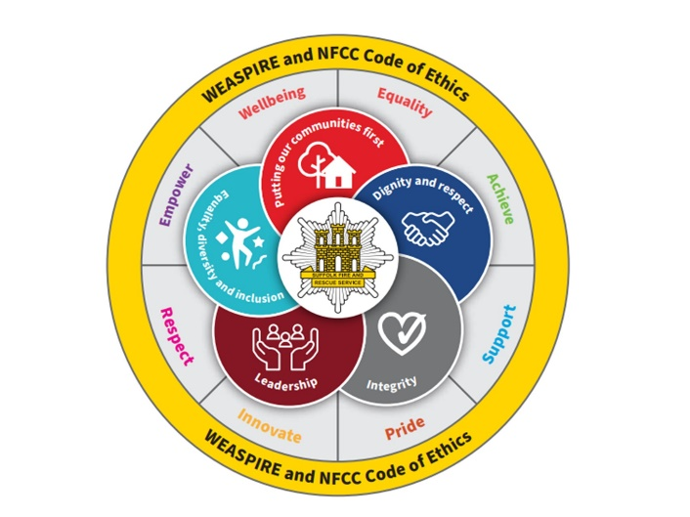

At Suffolk County Council our WE ASPIRE values set out the behaviours we expect from everyone in the organisation regardless of who they are, what their role or grade is or where they work. SFRS follow and promote the NFCC core code of ethics. Staff are required to role model our values and the code of ethics.

The values have been developed through feedback and input from employees at the council and underpin how we go about our everyday work. The core code of ethics sets our five principles to promote good behaviour and enhance service culture. They define us and help us to be the best we can be.

Visit our careers pages for more information on our WE ASPIRE values.

Our Customer Commitment



In addition to our WE ASPIRE values, we also have a Customer Commitment which sets out a number of strong principles that help support high standards of customer service and care that we can all endeavour to consistently demonstrate.

For more information, view our Customer Commitment poster.

More information for recruitment applicants

We offer a fantastic working environment including diverse and active staff networks,
great flexible working options and many benefits, as well as the opportunity to improve the lives of Suffolk residents.

Visit the Suffolk County Council career website to learn more, including information about adjustments to recruitment processes, our interview schemes and other commitments to equality, diversity and inclusion.

