Job Description

Job Title: Lecturer in Electrotechnical

Responsible to: Head of Building Services Engineering/Construction Multi-Trades

Functional Liaison with: Internal Verifiers, Course Directors, Course Teams, and Staff both within
and outside the department as required
Main Purpose: To teach on a range of programmes within the electrical services
section.

Main Duties and Responsibilities

The following duties are not shown in order of priority or frequency, nor is the list comprehensive, but rather an indication of the type and level of duties expected of the post.

- Teach and assess on a range of Electrotechnical including apprenticeship programmes at levels 1 to 3, short courses as required by the Head of Department.
- Act as tutor to Electrotechnical students on full time or part-time programmes liaising with employers as required.
- Participate in the development of existing and new course programmes and to assume responsibility for areas of work as appropriate.
- Participate in course team meetings, curriculum planning and materials development as appropriate.
- Assist with marketing and publicity of all courses within the department as required.
- Attend Parent, Career and other evenings as appropriate.
- Participate in the development and delivery of short course programmes.
- Act as mentor to new members of staff and give support to other new team members.
- Liaise with schools, moderators, assessors, industrial bodies and employers as appropriate.
- Liaise with internal and/or external verifiers as appropriate.
- Carry out general duties attached to the post on the College premises.
- Teach at any of the College’s Regional centres.
- Support and assist the Course Directors with the organisation and management of the Electrotechnical provision within the school.
- Undertake any other duties as directed by the principal or by delegated authority.
- Promote sustainability through teaching, learning and learner engagement activities, helping learners develop the knowledge, skills and behaviours needed for a more sustainable future.
- The above job description is not exhaustive, and the employee may be required to undertake any other reasonable duties in line with the general level of responsibility of the role.
- As we now operate as a collective Eastern Education Group you may be from time to time required to undertake any of the requirements of your role for any of our Group organisations.

PERSON SPECIFICATION

 | Essential | Desirable | Measured
Education and Qualifications | - Level 3 in Electrical Installation (or equivalent) and AM2 or 18th Edition are essential for this role.  - Assessors Award and Verifiers Award. | - Knowledge of Heat Pumps.  - Possession of a Certificate in Education, PGCE or other higher teaching qualification. | I,A,
Knowledge and Skills | - Knowledge of, and the ability to teach a variety of Electrotechnical subjects.  - Good communication skills.  - Good IT skills.  - Good customer service skills.  - Ability to teach practical and theory. |  | A,I,P
Experience | - Previous industrial experience working in Electrotechnical.  - Experience of teaching. | - Experience of working with young people in an FE environment. | A, I,
Personal Qualities | - Ability to work with young people in a supportive way.  - Ability to work as part of a team.  - Enthusiastic about all aspects of Electrotechnical.  - Possess a flexible approach to the delivery of services. |  | A, I,
Training | - Willingness to attend, undertake any training or development as, or when appropriate.  - Commitment to continuing personal development through continual professional learning. |  | A, I,

KEY: A-APPLICATION, I-INTERVIEW, P-PRESENTATION/MICROTEACH, T-TEST

Conditions of Service

- 52 days holiday, plus bank holidays (pro-rata for part-time hours).

- New appointments to the College are subject to a twelve-month probationary period.

- Contributory pension: Teachers Pension TPA.

- This College is committed to safeguarding and promoting the welfare of young people and vulnerable adults and expects all staff and volunteers to share this commitment.

- The job description is current at the date shown; it may change from time to time in negotiation with the post holder.

We are passionate about promoting equality of opportunity and creating a working environment where diversity is recognised and celebrated and everyone has the chance to reach their full potential. Our environment is diverse in character and student population. We particularly welcome applications from candidates from Black Minority Ethnic origin and those with a disability.
Eastern Education Group is committed to safeguarding our children and young people/vulnerable adults. We uphold fundamental British Values and expect all our employees to do the same. All appointments are subject to safer recruitment checks, including previous employment checks, online searches and an Enhanced DBS Check.

General Data Protection Regulations (GDPR)
In line with national legislation, and organisational policy, all data will be processed in a fair and lawful way, for the specific purpose and not disclosed in any way incompatible with such purpose or to any unauthorised persons or organisations.

Equal Opportunities
In accordance with the Equality Act 2010 the Group operates a policy of equality and diversity which protects employees, students and people who access the Group’s goods, services and facilities, from discrimination on the basis of ‘protected characteristics’ which include: age, disability, gender, reassignment, marriage and civil partnership, pregnancy and maternity, race (colour, nationality and ethnic or national origins.), religion or belief, sex and sexual orientation.

DBS
The successful applicant will be required to complete and obtain a standard or enhanced disclosure check (role dependant) from the Disclosure and Barring Service. The cost of processing this will be £40 (Enhanced), and you will be required to make payment online via the safeguarding website before your employment commences. Further information about the Disclosure and Barring Scheme can be found at www.homeoffice.gov.uk or by speaking to a member of the Human Resources department.

Lecturing Pay Scales
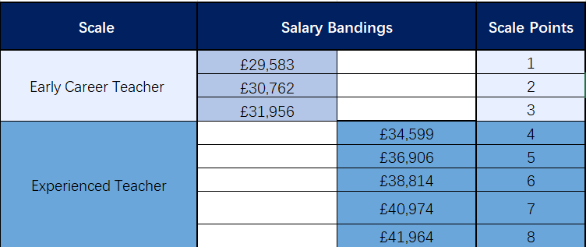
To progress onto our Experienced Teacher Scale, you must hold a Level 5 teaching qualification or an equivalent. This ensures you have the advanced knowledge and skills required to excel in the role, support student learning effectively, and contribute to the continuous development of our educational standards. Exceptions to this requirement will be reviewed on a case-by-case basis, considering experience, expertise, and individual circumstances.



Group Character Strengths
We have eight Group character strengths that underpin all we do and we make it a priority to give our students the strength of character in order to shine above the rest when faced with employers or universities.
Not only do they apply to our students but also to our staff members and the reasons why Eastern Education Group is such a fantastic place to work.
Take a look below:
- Resilience – We are strong as an organisation and all teams work together to achieve. If and when we are faced with challenges we respond efficiently and effectively at all times.
- Optimism – We use education as a catalyst for positive social change and prosperity for the community we serve, leaving no-one behind. We want to inspire our students.
- Curiosity – We are a curious organisation, always trying to seek out new opportunities and ways in which we can break boundaries in the world of education.
- Confidence – We are confident. We believe in all that we do and we appreciate the abilities and qualities of every single staff member. We celebrate our successes and we remain sure that we will continue to lead as a provider of education.
- Ownership – We take responsibility for every single student and every single staff member ensuring our main goal is that everyone at the Group is happy and achieving to their full potential. Our amazing wraparound support demonstrates this perfectly.
- Self-Control – We are disciplined as individuals and always put the needs of our students first.
- Ambition – We are an ambitious organisation. We are constantly evolving as demonstrated with the new STEM Innovation Campus.
- Respect – We respect our staff and students alike and we put the success of our students at the heart of all that we do, preparing them for their future.

