**JOB INFORMATION PACK**

Cleaner

**Welcome to Fairfield Infant and Colneis Junior Schools**

Thank you for your interest in the position of a cleaner at the Federation of Fairfield and Colneis. We hope this pack will provide some useful information about Fairfield Infant and Colneis Junior Schools and the type of person we are looking to appoint to add to the dedicated and talented team of the Federation.

Our popular infant and junior schools, based on separate sites, have been successfully collaborating for around 15 years and in a Federation for 10 years. We are seeking to appoint a cleaner who:

* Is flexible, enthusiastic, reliable and hardworking
* Are good at working in a team
* Will form positive relationships within the school community
* will uphold the strong caring ethos and inclusive environment of both schools

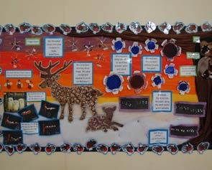

In return, we can offer you a welcoming, friendly and supportive staff team.

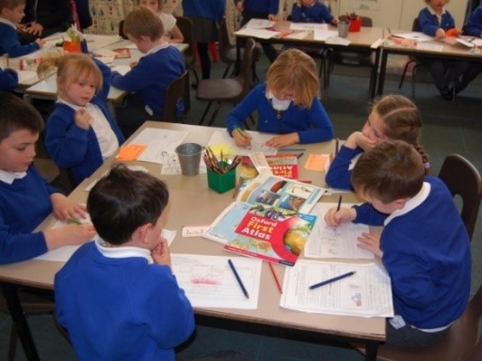

**Fairfield Infant School**

High Road West

Felixstowe

Suffolk

IP11 9JB

**fairfieldoffice@**

**fairfieldandcolneis.co.uk**

**Colneis Junior School**

Colneis Road Felixstowe Suffolk

IP11 9HH

**colneisoffice@**

**fairfieldandcolneis.co.uk**

[**www.fairfieldandcolneis.co.uk**](http://www.fairfieldandcolneis.co.uk)

(web-site for both schools)

**Our Location**

Our schools are in Felixstowe, a vibrant town on the coast of East Anglia, less than two hours away from London, an hour from Stansted airport and links to Europe via Harwich. Suffolk boasts blue flag beaches and seaside towns with literary festivals and activities to appeal to people of all ages. Felixstowe is close to a number of national and international cultural destinations such as Aldeburgh, Southwold and Woodbridge. You will find great places to eat, theatre and art centres as well as beautiful countryside to explore with nature reserves and picturesque villages.

**Our Federation**

You will have the opportunity to work with staff across both school sites, which are less than half a mile apart located close to Felixstowe town centre. We offer our staff development opportunities which encompass both schools and allow opportunities for collaboration and knowledge sharing. Both Colneis and Fairfield have access to a shared swimming pool and compete in local schools’ sports activities and tournaments.

**Fairfield Infants**

At Fairfield, with our friendly and caring atmosphere, we provide day school education for an average of 270 boys and girls aged between 4 and 7 years, including Nursery provision.

There has been a school on this site since 1879 and we are very proud of our beautiful Victorian buildings and £500,000 extension providing a new school entrance, offices and a magnificent hall. Outdoor facilities include a playing field, adventure playground, wildlife area together with spacious hard play areas.

**Colneis Junior**

At Colneis, with our broad and creative curriculum to motivate and inspire our pupils, we provide education for boys and girls aged between 7 and 11 years. The current school roll is 352.

Our school was built in the 1960s and provides accommodation for pupils in year groups that are accessed from the main hall. As with Fairfield, our outdoor facilities include a playing field, wildlife area, hard play areas and a Millennium garden. We are very proud of our covered, heated swimming pool.

We have dedicated staff, many supportive parents and a committed governing body. It is important to us that our pupils enjoy learning and feel secure during their time with us so that when they leave they have the skills and confidence to succeed.

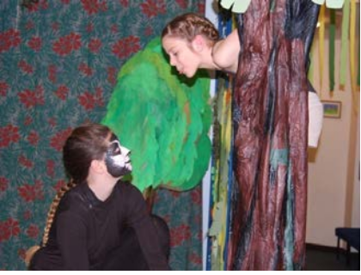**Our Children**

Our children are kind, considerate and respectful to each other, staff and visitors. They consistently meet the schools’ high expectations and

comments from visitors confirm this view.

The children have many talents which we are proud to showcase within our local community; we are well known for our sporting achievements and outstanding school productions!

**Our Staff**

The most important resource we have is our staff. They are totally committed to promoting life-long learning through a challenging curriculum and work with parents as partners

to encourage our pupils to exceed expectation.

We take the wellbeing of our staff seriously, striving to both encourage and achieve a good work-life balance. We like to support our staff to further their professional development

based on individual, personal and school needs, in line with our performance management process.

We have 28 qualified teachers across both schools in full and part time rolls. They work hard to make sure that the children are nurtured, challenged and inspired.

In addition, we have 44 support staff across both schools in full and part time roles, covering a range of roles including apprentices, teaching assistants and Thrive practitioners. PPA cover is also provided by HLTAs and a team of instructors.

Full time family pastoral support is provided across both schools and we also employ six support staff to manage our finance, HR, administration and site functions. A team of midday staff lead and supervise a range of lunchtime activities.

**Our Ethos and Values**

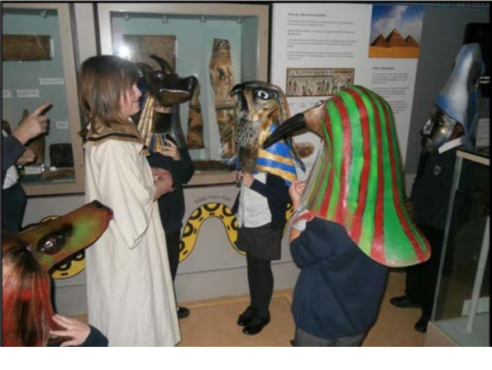

**Together we’re better**

Our core values are –

* Acceptance
* Compassion
* Trust
* Honesty
* Gratitude
* Courage
* Respect
* Forgiveness

Our school charter –

* We always do our best
* We are kind, helpful and gentle
* We learn from our mistakes
* We are safe because we care for people and property

**Our staff will**

• Keep our pupils at the centre of our decision making

• Promote high expectations for every pupil, for both learning and behaviour

• Provide the best quality teaching and learning

• Listen to our pupils

• Know, share and provide the next steps in learning for every pupil

• Keep the safeguarding of all children at the heart of all that we do and follow rigorous procedures to promote safeguarding throughout both schools

**Parents’ Survey**

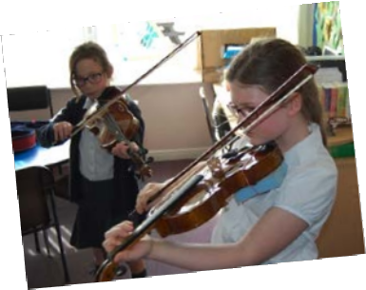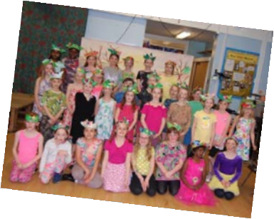

Our latest Ofsted Parent View results

show that:

* 100% of parents agreed that their child was well looked after at Fairfield

• 98% say there child is happy at Fairfield and Colneis

• 98% of parents agreed their child feels safe at school

• 98% of parents agreed that their child does well at Fairfield and Colneis

**What Ofsted say about our schools**

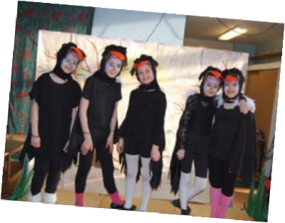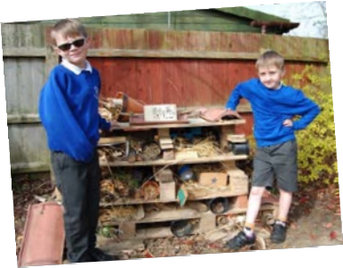

“Pupils [at Fairfield] respond very positively to teachers’ high expectations of behaviour and learning. They take pride in sharing their work and their successes. They try their best in lessons. They are not afraid to make mistakes, believing that this helps them to learn better.’

‘Pupils [at Colneis] love attending this friendly school. They appreciate the many opportunities staff give them. Pupils are keen to learn. They share what they know with each other and with adults. They particularly enjoy and get excited about the outdoor learning.’

**… about our Leaders and Governors:**

‘Leaders have built positive relationships with pupils, parents and staff, all of whom

express great confidence in leaders. Staff are proud to work in the school. Leaders

support staff well. The governing body and local authority have closely monitored

the school’s improvement plans and visit the school regularly.’

‘Governors share the passion of leaders to ensure that pupils do the best they can while they are at Fairfield Infant School. They have been proactive in exploring ways to ensure that leaders are enabled to successfully lead across the federation.’

‘Leaders have designed an ambitious curriculum. This identifies the important knowledge that pupils need to know and remember, and the order they need to learn it. The curriculum is designed to help pupils make connections between their learning in different subjects. Consequently, pupils develop a detailed knowledge in most subjects and learn well.’

**… about our Staff:**

‘Teachers use highly effective questioning that encourages pupils to discuss and think about their learning.’

‘Teachers are enthusiastic and have good subject knowledge. As a result, pupils achieve well across the school.’

‘Teachers and support staff work well together to make learning interesting and enjoyable, and provide additional help for pupils who need it. Their coordinated work ensures that classrooms are busy, purposeful and productive.’

‘The leadership of special educational needs and/or disabilities is very effective. The special educational needs coordinator … has ensured that adults have received well-targeted training to enable them to very effectively support individual pupils, some with complex needs.’

**What parents said to Ofsted …**

‘This (Fairfield) is a fantastic school’

‘Support has been phenomenal in this really amazing school’

‘I can’t tell you how wonderful it is to know that my child is safe, secure and in a caring environment’

‘Colneis provides a very safe and nurturing environment in which my child has

flourished.”

**THE FEDERATION OF FAIRFIELD AND COLNEIS**

**Post Title: Cleaner**

**Reporting to: Site Manager**

**Grade: 1**

Under the direction of the Site Manager, the post holder is responsible for ensuring the school buildings are cleaned to the standard required.

No supervisory responsibilities.

All duties are carried out within recognised procedures or guidelines.

All problems, other than the most routine or straight forward, will be referred to the Site Manager.

**Examples of duties**

**Cleaning**

* General cleaning duties of an allocated area of the appropriate school.
* Emptying waste bins, ensuring that recycling is separated.
* Reporting any damage to the Site Manager.
* Cleaning and maintenance during school closures.

The duties and responsibilities of this post may vary from time to time and post holders may be expected to undertake other duties of a similar level / nature which is considered appropriate to the level of this post.

Although the posts are based at one school, there may be times when the post holder will be asked to work

at the other school.

In addition, all duties must be carried out in accordance with health and safety procedures, as follows:

* Wearing personal protective equipment and clothing eg, rubber gloves
* Correct use of colour coded equipment and consumables e.g. cloths, gloves to prevent cross contamination
* Safe care and correct use of cleaning chemicals
* Use of ‘dirty kit’ in disposing of bodily fluids
* In the event of an accident, refer to COSSH data sheet for guidance

*The duties and responsibilities of any post may change from time to time, and post holders may be expected to carry out other work not explicitly mentioned above which is considered to be appropriate to the existing level of responsibility vested in the post.*

**Person specification**

* A sound knowledge of health and safety is desirable.
* The ability to use a range of cleaning equipment.
* Ability to communicate clearly with a wide range of people and follow instructions.
* Adequate literacy skills.
* Ability to prioritise work and manage time effectively.
* Be flexible to the changing demands of the post.
* Work as a team.
* Take pride in a job well done.
* Using initiative and the ability to work without supervision.

**Job details**

* Post based at Fairfield Infant School although the post holder may be requested to work at Colneis Junior School by prior arrangement (contracts are issued across the Federation).
* Start date is as soon as possible.
* This is a permanent contract.
* Grade 1 point 1 (£22,367 pro rata)
* 10 hours per week (4pm-6pm Monday to Friday)
* 44 weeks per annum (term time plus 6 weeks during the holidays).
* Any additional training will be given as necessary.