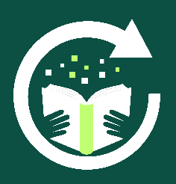

Alternative Provision
Reboot Education
REBUILD - REINTEGRATE - REDISCOVER

Provision Teacher (Ipswich) Information Pack
September 2026
Dear Applicant

Thank you for your interest in the role of Provision Teacher at Reboot Education – Ipswich. In this pack you will find some additional information about the role and how to apply for the post.

Information about the Role:

Name of Role: | Provision Teacher (Part-Time)
Contract Type: | Permanent
Working Days & Hours: | Monday to Wednesday, 9 am to 3 pm, term-time only.
Start Date: | Monday 4th January 2027
Pay Range: | £25,380 to £26,790 (actual take home salary) per annum per year
Location of Role: | Reboot Education Ipswich Campus.  8 Delta Terrace, West Road, Masterlord Village, Ipswich, Suffolk. IP3 9FH

We are looking to recruit a Provision Teacher (part-time), for 3 days a week, (Monday to Wednesday).

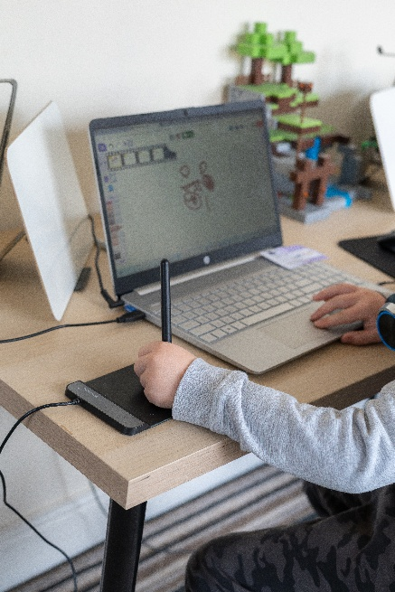
This role will focus on delivering core curriculum and wider curriculum learning to small groups of students from Key Stages 2 to 4. The focus is on addressing gaps in the students’ knowledge for reading, writing and maths and preparing them for the next steps in their learning journey. A typical lesson (learning activity) will last for about 45 minutes.

It is desirable (but not essential) that applicants have some experience of teaching maths and English across key stages 2 to 4. For this role, experience of teaching Computing is not essential.

The main purpose of all roles at Reboot Education is to support students in re-engage in their learning and build their self-confidence through the teaching of computer skills, cookery, core subjects as well as the use of interventions to address areas of need. On a daily basis there will always be 2 teachers and 4 Student Support Assistants on site with a maximum of 10 students onsite daily.

This role has been created due to increased demands for our service which has resulted in a need to release our Director of Education from their teaching responsibilities.

About Reboot Education
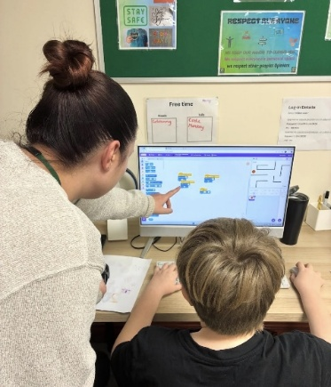
Reboot Education was founded by Paul Arch and Viv Hunt. Both Paul and Viv were experienced senior school leaders before setting up Reboot Education. Paul and Viv opened their first alternative education provision in central Ipswich at the start of 2024. Since opening the provision, demand for our service has increased greatly over the last year, which has resulted in Reboot Education opening a second provision in Bury St. Edmunds and moving to a larger base in Ipswich which opened at the start of the Summer Term 2026.
Our provisions are purposefully small and are set up not to feel like a conventional school. We support up to 6 students per day in our Bury Provision and up to 10 students at our larger Ipswich provision.

The students who access our provision attend from 1 to 3 days per week and are usually struggling to maintain their mainstream school place. We use a computing and technology-based curriculum to re-engage the students in learning and to help them rediscover their self-esteem and confidence.

Our provision days start at 9.30 am and finish at 2.30 pm. We normally give the students the first 30 minutes of the day to come in and have breakfast and complete a settling task. At 10 am we start the first learning activity of the day, with a break at around 11 am. Following the morning break there is another learning activity and then at 12pm we stop for a lunch break. Between 1pm and 2.00 pm the students complete a final learning activity and then if they have worked hard, they have some reward time before they leave at 2.30 pm. Most of our students travel to and from Reboot Education via Taxi.

Location of the Role:
This role will be based at our Ipswich provision, which is located at 8 Delta Terrace, West Road, Masterlord Village. The building is on two levels with well-equipped teaching spaces on both floors. This building will open as our provision base from April 2026, as we are moving from our current location, due to the need for more space.
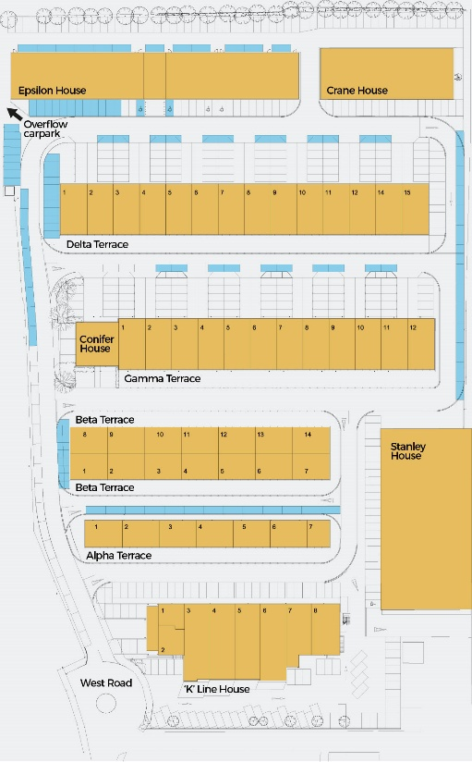
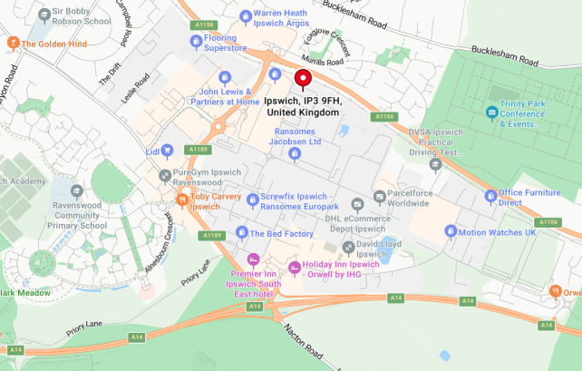
There is plenty of free onsite parking with a local café just a minutes’ walk and a children’s nursery also located at Masterlord Village. The site is easily accessible and is just 5 minutes from the Ransomes A14 junction.

Why work at Reboot Education:
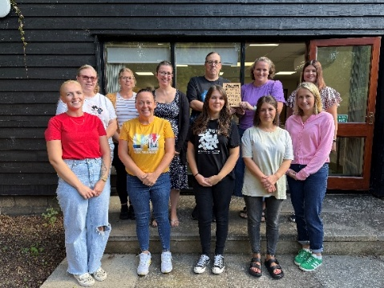
Since Reboot Education opened, we have grown from a team of 2 to a team of 15 in two and half years, across our two sites. Our staff retention has been 100% which we believe is down to developing a team that all share and believe in our core values and support each other.
We also offer,
- Competitive rates of pay.
- A chance to help develop our innovative alternative education provision.
- Regular training.
- Supportive Senior Leaders.
- Employee Assistance Programme.
Working at Reboot has reaffirmed why I chose to become a teacher. Each day provides the opportunity to make a meaningful difference to a young person's life, helping them re-engage with learning and build confidence to recognise their potential.
-Danielle, Provision Teacher, Bury St. Edmunds.



Reboot is a great place to work. We work as a team and support each other, both professionally and personally. Every day is different and we make such a difference to the student’s lives. It’s inspiring to see the progression our students make whilst they have been attending Reboot Education.
-Gemma, Provision Teacher, Ipswich.



You will need:

Essential: | Desirable:
- Qualified Teacher Status.  - A clear enhanced DBS check.  - A passion for working with young people that have complex needs and some knowledge of SEND.  - Experience of teaching core curriculum subjects and interventions.  - Be engaging and motivating.  - Be reflective and open to new approaches.  - Good communication skills. | - Have experience of working with students at either Key Stages 2, 3 or 4.  - Experience of working with students with social, emotional and behavioural difficulties.

For more information:
For an informal discussion, please contact Mr Paul Arch or Viv Hunt on (01473) 970611 or by email at hr@reboot-education.co.uk Visits to our provision in Ipswich are welcomed. You can also learn more about Reboot Education by visiting our website at www.reboot-education.co.uk

How to apply:
To apply for the role, please download and complete our application form. CVs will not be accepted unless accompanied by our official application form. Completed application to be returned to Reboot Education by email at hr@reboot-education.co.uk or by post to 8 Delta Terrace, West Road, Masterlord Village, Ipswich, Suffolk. IP3 9FH.

Closing Date for Applications: | 10.00 am on Monday 12th October 2026.
Planned Interview Date: | Thursday 15th October 2026

