Suffolk User Forum
Coproduction and Lived Experience Lead
Recruitment Pack
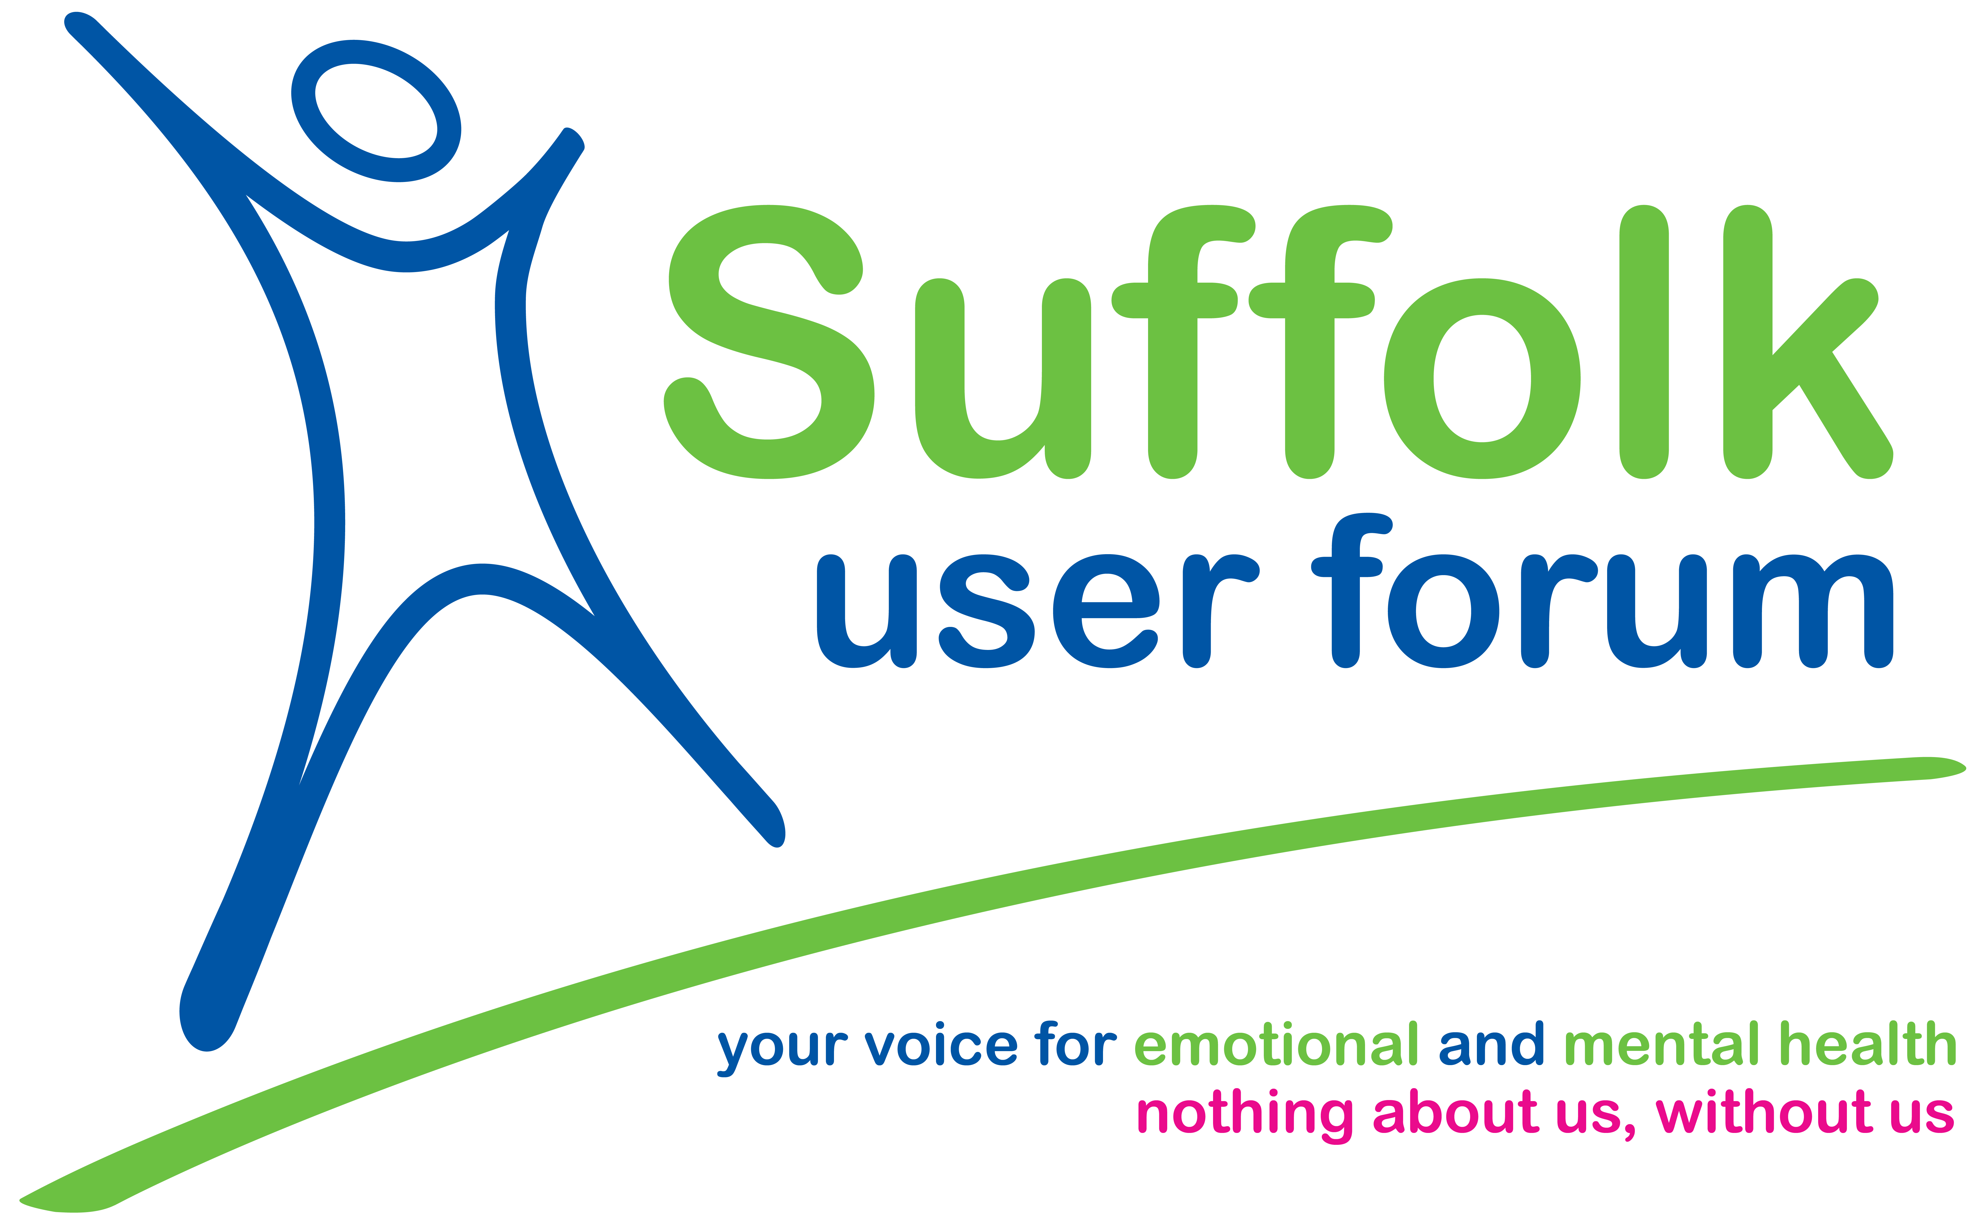

About SUF
Suffolk User Forum is an independent organisation led by lived experience. We make sure people’s real voices shape mental health services, guided by the principle ‘nothing about us, without us’. Our vision is for lived experience to be at the heart of mental health services. Our mission is to support people with lived experience—including people in primary care, secondary care and inpatient settings—to influence service design, delivery and decisions through inclusive, co-created spaces.
Our 2026–2029 strategy focuses on building community and connection, embedding coproduction, strengthening self-advocacy, and growing membership, supported by accessible engagement and strong partnerships.

Role Summary (Advert)
Help us make ‘nothing about us, without us’ a reality. We’re looking for a warm, values-led leader to embed coproduction across Suffolk User Forum and help the wider Suffolk mental health system do the same. You will manage a Lived Experience Coordinator and a Volunteer Coordinator, lead our quarterly Coproduction Steering Group and working groups, and represent Suffolk User Forum in coproduction and engagement programmes with the Integrated Care Board and Suffolk County Council. You will also lead internal and external coproduction projects, keep lived experience central to service design and to how we work, and write clear reports for our Chief Executive Officer and Board.

Job Details
Details
Organisation: | Suffolk User Forum
Job Title: | Coproduction and Lived Experience Lead
Reports to: | Chief Executive Officer
Line Management Responsibilities: | Lived Experience Coordinator; Volunteer Coordinator and volunteers.
Location: | Office based with some opportunity for hybrid working. Postholder will work across Suffolk (travel to partners/communities as required)
Hours: | Part-time (30 hours/four days a week)
Salary: | NJS Pay Scale P03/SCP 32  £42,839 pro rata/£22.23 an hour
Contract: | Permanent
Probation: | Three months
Pre‑employment checks: | Right to work; two references; enhanced Disclosure and Barring Service check.

Description

1. Purpose of the Role
This role helps Suffolk User Forum bring coproduction to life, so lived experience is at the heart of everything we do. You will also support partners across Suffolk to put lived experience at the centre of mental health service design. You will combine strategic leadership with hands-on delivery, build strong relationships, and help deliver our 2026–2029 priorities on people’s voices, community engagement and coproduction.

2. Key Responsibilities

A. Leadership & governance
- Provide visible, values-led leadership, ensuring SUF’s strategy is delivered with integrity and impact.
- Lead coproduction in line with our 2026–2029 strategy, ensuring lived experience (including voices less often heard) shapes SUF’s work and governance.
- Chair (minimum quarterly) the Coproduction Steering Group and working groups, ensuring agendas, papers and follow-up actions are co-produced and accessible.
- Produce clear updates and reports on coproduction for the CEO, Board and members, aligned to our reporting cycle.

B. Partnerships
- Represent SUF with the ICB, Suffolk County Council, NHS partners and VCSE organisations, building trusted relationships and influence.
- Support people with lived experience to participate in recruitment, tenders, programme boards and service redesign.
- Lead coproduction projects end-to-end with clear outcomes, fair involvement and on-time delivery; support the CEO to shape projects for funding bids.
- Deliver strategy priorities, including Conversation Cafés, focus groups and Stepping Forward events, and support self-advocacy resources and programmes.

C. Collaborative working
- Provide visible, values‑driven leadership, working closely within the SUF leadership team to drive the team’s focus on our purpose, and ensure that our strategy is delivered with integrity and impact.
- Line management of the Lived Experience Coordinator and Volunteer Coordinator, providing supportive supervision, reflective practice and clear planning.
- Support volunteer pathways, ensuring clear boundaries, good support and safe practice; help grow future lived-experience leaders.
- Create safe, welcoming spaces online and in person, removing barriers so more people can take part (including carers and families).
- Set up simple feedback and impact measures; keep accurate records and handle information safely and legally.
- Work collaboratively with the CEO, trustees and colleagues so SUF’s language and materials reflect our vision, mission and people-centred approach, and grow SUF membership through our activities.

Person Specification
Criteria | Essential | Desirable | Assessment Method
Qualifications & Training | - Relevant qualification or equivalent experience (coproduction, mental health, lived experience leadership, community development or similar).  - GCSE Math’s and English (or equivalent). | - Qualifications in mental health, social care, coaching or management.  - Commitment to ongoing professional development. | Application / Interview
Experience | - Leading coproduction and/or lived-experience involvement.  - Writing clear reports and updates for different audiences. | - Designing/delivering workshops, training or community sessions.  - Supporting self-advocacy or peer-led initiatives.  - Working with statutory and community organisations.  - Line managing staff and/or volunteers. | Application / Interview
Knowledge & Understanding | - Understanding of coproduction and lived-experience-led involvement.  - Understanding of mental health and the needs of people who use services.  - Knowledge of safeguarding and data protection. | - Knowledge of Suffolk mental health services and community support.  - Familiarity with coproduction models (e.g., coproduction ladder). | Application / Interview
Skills & Abilities | - Communication and facilitation skills.  - Able to build trusting relationships and work collaboratively.  - Good organisation and ability to manage priorities.  - Confident using Microsoft applications. | - Designing and delivering presentations/training.  - Monitoring, evaluation or impact measurement.  - Leading, motivating and supporting staff/volunteers. | Application / Interview
Values & Behaviours | - Commitment to SUF values.  - Acts in SUF’s best interests; maintains confidentiality; champions equality and diversity; accountable and open to learning. | - Reflective practitioner. | Interview
Other Requirements | - Able to travel across Suffolk (driving license and access to own transport).  - Willingness to work flexibly, including occasional evenings/weekends. |  | Application / Interview

How to Apply & Accessibility
To apply, please send: an application form that shows how you meet the essential criteria.
We want the application process to feel straightforward and supportive. If you would like this pack in a different format, or you need any reasonable adjustments at any stage, please get in touch and we will do our best to help.
If you would like an informal chat about the role before applying, you are very welcome to arrange a conversation with Jayne, our Chief Executive Officer, by calling 01473 907087.
Email your application to: hello@suffolkuserforum.co.uk.
If you have any questions before you apply, please feel free to email us—we will be happy to help.
Key dates: Closing date – 12:00 noon, Friday, 10th July 2026
Stage 1 - Interview Dates – Tuesday 14th July 2026
Stage 2 - Lived Experience Panel Date: Thursday 16th July 2026
Recruitment Process.
As part of the recruitment process, applicants will take part in a formal interview with the CEO, a nominated trustee and a volunteer. Candidates who are successful at stage 1 will then be invited to stage 2, where they will be invited to attend a 20-30 minute lived experience panel which they will lead/facilitate, presenting a response to the following question:
“Can you tell us about a time when you helped make sure people with lived experience had a real influence on a piece of work or decision? What did you do, and what difference did it make?”
Applicants are asked to provide the agenda for the lived experience panel together with their application form by the closing date, so that panel members can prepare in advance.

