JOB INFORMATION PACK

Sports Coach

Welcome to the Federation of Fairfield and Colneis

Thank you for your interest in the position of a sports coach at the Federation of Fairfield and Colneis. We hope this pack will provide some useful information about Fairfield Infant and Colneis Junior Schools and the type of person we are looking to appoint to add to the dedicated and talented team of the Federation.

Our popular infant and junior schools, based on separate sites, have been successfully collaborating for around 14 years and in a Federation for 9 years. We are seeking to appoint a sports coach who:

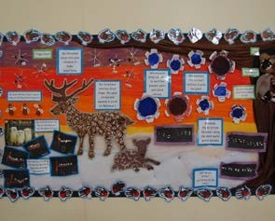


- has a knowledge of physical fitness
- has experience of coaching sports to children in a school setting
- has good communication skills with a variety of age groups
- is able to work independently and as part of team
- is able to manage class discipline effectively
- is able to plan for progression of pupil games and PE skills

In return, we can offer you:

- welcoming and hardworking colleagues
- a positive and friendly atmosphere for children to enjoy their learning
- enthusiastic pupils
- committed governors
- a commitment to your personal development

We look forward to receiving your application.

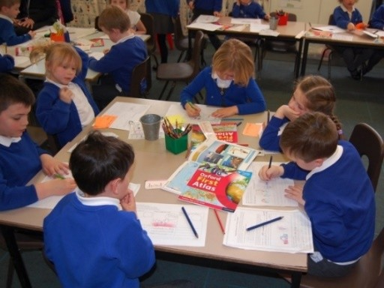

Fairfield Infant School
High Road West
Felixstowe
Suffolk
IP11 9JB

fairfieldoffice@
fairfieldandcolneis.co.uk

Colneis Junior School
Colneis Road Felixstowe Suffolk
IP11 9HH

colneisoffice@
fairfieldandcolneis.co.uk

www.fairfieldandcolneis.co.uk
(web-site for both schools)

Our Location
Our schools are in Felixstowe, a vibrant town on the coast of East Anglia, less than two hours away from London, an hour from Stansted airport and links to Europe via Harwich. Suffolk boasts blue flag beaches and seaside towns with literary festivals and activities to appeal to people of all ages. Felixstowe is close to a number of national and international cultural destinations such as Aldeburgh, Southwold and Woodbridge. You will find great places to eat, theatre and art centres as well as beautiful countryside to explore with nature reserves and picturesque villages.

Our Federation
You will have the opportunity to work with staff across both school sites, which are less than half a mile apart located close to Felixstowe town centre. We offer our staff development opportunities which encompass both schools and allow opportunities for collaboration and knowledge sharing. Both Colneis and Fairfield have access to a shared swimming pool and compete in local schools’ sports activities and tournaments.

Fairfield Infants
At Fairfield, with our friendly and caring atmosphere, we provide day school education for an average of 270 boys and girls aged between 4 and 7 years, including Nursery provision.

There has been a school on this site since 1879 and we are very proud of our beautiful Victorian buildings and £500,000 extension providing a new school entrance, offices and a magnificent hall. Outdoor facilities include a playing field, adventure playground, wildlife area together with spacious hard play areas.

Colneis Junior
At Colneis, with our broad and creative curriculum to motivate and inspire our pupils, we provide education for boys and girls aged between 7 and 11 years. The current school roll is 352.

Our school was built in the 1960s and provides accommodation for pupils in year groups that are accessed from the main hall. As with Fairfield, our outdoor facilities include a playing field, wildlife area, hard play areas and a Millennium garden. We are very proud of our covered, heated swimming pool.

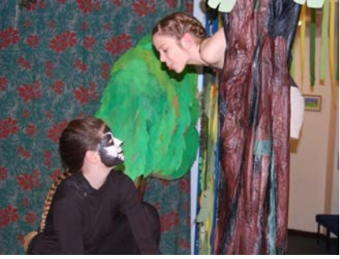
We have dedicated staff, many supportive parents and a committed governing body. It is important to us that our pupils enjoy learning and feel secure during their time with us so that when they leave they have the skills and confidence to succeed.
Our Children
Our children are kind, considerate and respectful to each other, staff and visitors. They consistently meet the schools’ high expectations and
comments from visitors confirm this view.

The children have many talents which we are proud to showcase within our local community and beyond.

Our Staff
The most important resource we have is our staff. They are totally committed to promoting life-long learning through a challenging curriculum and work with parents as partners
to encourage our pupils to exceed expectation.

We take the wellbeing of our staff seriously, striving to both encourage and achieve a good work-life balance. We like to support our staff to further their professional development
based on individual, personal and school needs, in line with our performance management process.

We have 28 qualified teachers across both schools in full and part time rolls. They work hard to make sure that the children are nurtured, challenged and inspired.

In addition, we have 44 support staff across both schools in full and part time roles, covering a range of roles including apprentices, teaching assistants and Thrive practitioners. PPA cover is also provided by HLTAs and a team of instructors.

Full time family pastoral support is provided across both schools and we also employ six support staff to manage our finance, HR, administration and site functions. A team of midday staff lead and supervise a range of lunchtime activities.


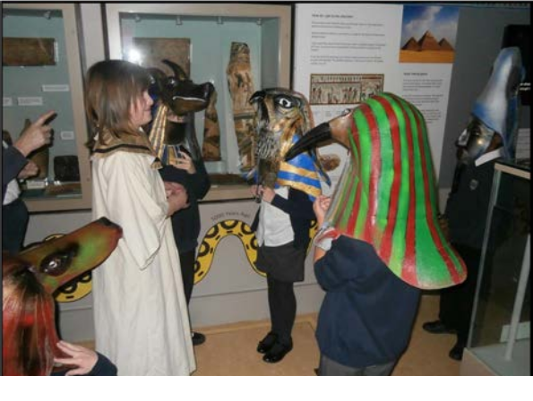

Our Ethos and Values

Together we’re better

Our core values are –

- Acceptance
- Compassion
- Trust
- Honesty
- Gratitude
- Courage
- Respect
- Forgiveness

Our school charter –

- We always do our best
- We are kind, helpful and gentle
- We learn from our mistakes
- We are safe because we care for people and property

Our staff will

  - Keep our pupils at the centre of our decision making
  - Promote high expectations for every pupil, for both learning and behaviour
  - Provide the best quality teaching and learning
  - Listen to our pupils
  - Know, share and provide the next steps in learning for every pupil
  - Keep the safeguarding of all children at the heart of all that we do and follow rigorous procedures to promote safeguarding throughout both schools

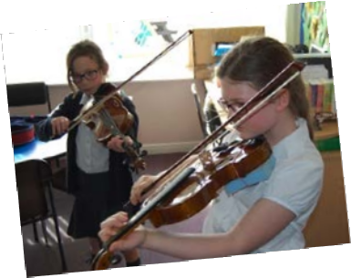



Parents’ Survey

Our latest Parent Survey results
show that:

• 100% of parents agreed that their child was well looked after at Fairfield
• 98% say there child is happy at Fairfield and Colneis
• 98% of parents agreed their child feels safe at school
• 98% of parents agreed that their child does well at Fairfield and Colneis

What Ofsted say about our schools



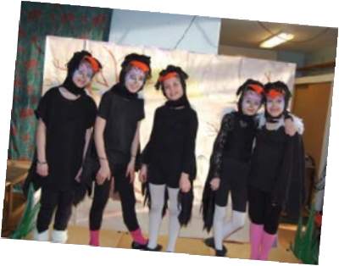

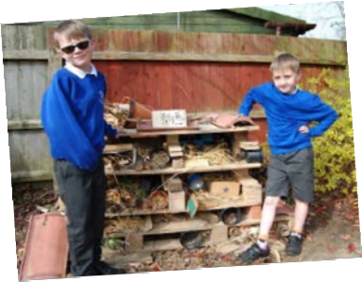

“Pupils [at Fairfield] respond very positively to teachers’ high expectations of behaviour and learning. They take pride in sharing their work and their successes. They try their best in lessons. They are not afraid to make mistakes, believing that this helps them to learn better.’

‘Pupils [at Colneis] love attending this friendly school. They appreciate the many opportunities staff give them. Pupils are keen to learn. They share what they know with each other and with adults. They particularly enjoy and get excited about the outdoor learning.’

… about our Leaders and Governors:

‘Leaders have built positive relationships with pupils, parents and staff, all of whom
express great confidence in leaders. Staff are proud to work in the school. Leaders
support staff well. The governing body and local authority have closely monitored
the school’s improvement plans and visit the school regularly.’

‘Governors share the passion of leaders to ensure that pupils do the best they can while they are at Fairfield Infant School. They have been proactive in exploring ways to ensure that leaders are enabled to successfully lead across the federation.’

‘Leaders have designed an ambitious curriculum. This identifies the important knowledge that pupils need to know and remember, and the order they need to learn it. The curriculum is designed to help pupils make connections between their learning in different subjects. Consequently, pupils develop a detailed knowledge in most subjects and learn well.’

… about our Staff:

‘Teachers use highly effective questioning that encourages pupils to discuss and think about their learning.’

‘Teachers are enthusiastic and have good subject knowledge. As a result, pupils achieve well across the school.’

‘Teachers and support staff work well together to make learning interesting and enjoyable, and provide additional help for pupils who need it. Their coordinated work ensures that classrooms are busy, purposeful and productive.’

‘The leadership of special educational needs and/or disabilities is very effective. The special educational needs coordinator … has ensured that adults have received well-targeted training to enable them to very effectively support individual pupils, some with complex needs.’

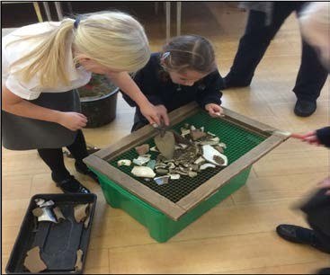
What parents said to Ofsted …

‘This (Fairfield) is a fantastic school’

‘Support has been phenomenal in this really amazing school’

‘I can’t tell you how wonderful it is to know that my child is safe, secure and in a caring environment’

‘Colneis provides a very safe and nurturing environment in which my child has
flourished.”

The Federation of Fairfield and Colneis

Job description: Sports Coach

Responsible to: Headteacher and Governors

Grade: 4

Job purpose

The PE and Sports Coach will ensure that there is consistent delivery of teaching, continuity in context and skills and high standards of learning throughout the school.

Duties

The Sports Coach will:

- Work alongside the PE Coordinators to develop a cohesive and effective long-term plan for PE for the whole school;
- Work alongside the PE Coordinators to ensure that medium term planning meets all National Curriculum requirements;
- Teaching PE across the school.
- Review, monitor and evaluate current practice (including schemes and policies) and provide feedback to the Senior Leadership Team;
- Support, motivate and advise staff by working alongside them in the development of their teaching practice, where appropriate;
- Lead by example, through exceptional teaching practice;
- Disseminate information to the staff and provide INSET to promote staff development and improve their teaching practice;
- Contribute to deep dives and action plans to support the development of the subject, in line with the School Improvement Plan;
- Maintain an up-to-date knowledge of local and national initiatives by attending relevant courses;
- To prioritise resource needs as indicated by the subject development plan;
- Provide assessment feedback to teachers for end of term reports;
- Support PE Coordinators in the planning and organisation of school sporting events, including team selection, training and transport

Support for the school

- Contribute to the development, implementation and evaluation of the school’s policies, practices and procedures, so as to support the school’s values and vision
- Promote the safety and well-being of pupils and help to safeguard pupils’ well-being by following the requirements of Keeping Children Safe in Education and our school’s child protection policy
- Be aware of and support difference and ensure all pupils have equal access to opportunities to learn and develop
- Contribute to overall ethos / work / aims of the school
- Attend and participate in relevant meetings as required
- Participate in training and other learning activities and performance development as required
- Assist with the supervision of pupils out of lesson times, including before and after school and at lunchtimes
- Accompany teaching staff and pupils on visits, trips and out of school activities as required and take responsibility for a group under the supervision of the teacher
The Sports Coach will be required to safeguard and promote the welfare of children and young people and follow school policies and the staff code of conduct.

Please note that this list of duties is illustrative of the general nature and level of responsibility of the role. It is not a comprehensive list of all tasks that will be required to be carried out. The postholder may be required to do other duties appropriate to the level of the role, as directed by the Headteacher.

Safeguarding

Our schools are committed to safeguarding and promoting the welfare of children and young people and we expect all staff to share this commitment. The post is subject to satisfactory references, health check and an enhanced DBS check.

The Federation of Fairfield and Colneis is a thriving school with a commitment to high standards and inclusion. We expect high standards of behaviour from the pupils; and the staff are determined to provide high quality teaching and learning opportunities for all pupils.

Job details

- Based at the Federation of Fairfield and Colneis – Fairfield Infant School, High Road West, Felixstowe, Suffolk, IP11 9JB and Colneis Junior School, Colneis Road, Felixstowe, Suffolk, IP11 9HH
- Salary: Grade 4 point 9 (£25,979) pro rata
- Contract: 5 days a week - 35 hours – 8.30am-4.30pm – 38 weeks per year
- Fixed term until 31 August 2025 although there is potential for it be extended
- Required from September 2024

Application

If you decide to proceed with your application, please send your completed application form to Libby Winton, School Business Manager, Colneis Junior School, Colneis Road, Felixstowe, Suffolk,
IP11 9HH or via email to sbm@fairfieldandcolneis.co.uk.

The closing date for applications is 12 noon on Thursday 23 May 2024 with interviews being held on Wednesday 5 June 2024.

Criminal convictions

The post for which you are applying is exempt from the Rehabilitation of Offenders Act 1974 because it involves substantial opportunity for access to children. You are, therefore, required to declare details of any criminal record you may have, including details of any convictions (even if they would otherwise be regarded as “spent” under this Act) or any cautions or bind-overs and any pending prosecutions. The information you give will be regarded as confidential and will only be disclosed in relation to this appointment.

If you are appointed, arrangements for a Disclosure and Barring Service check will be made to establish whether there is any criminal record in your name. Any information received will be kept in strict confidence.

The disclosure of a criminal record, or other information, will not debar you from appointment unless the LEA considers that it renders you unsuitable for appointment. In making this decision the Authority will consider the nature of the offence and any other factors which may be relevant.

Failure to declare a conviction, caution or bind-over may well disqualify you from appointment or result in your appointment being terminated when the discrepancy comes to light.

If you would like to discuss, in confidence, a previous conviction in relation to your application, please telephone HR on 0300 123 1420.

Equal Opportunities

Suffolk County Council is committed to achieving equality of opportunity in all its services.

Employees and prospective employees will not be unfairly discriminated against on grounds of their:

- gender
- marital status
- colour
- race
- nationality
- disability
- ethnic or national origin
- religion
- age
- trade union membership or non-membership
- sexual orientation

Where an employee may be disadvantaged on these grounds, the County Council will make every reasonable effort to rectify such disadvantage(s).

Employment terms and conditions and decisions on recruitment, selection, training, promotion, dismissal, payment and conditions and health and safety and welfare will be made solely on the basis of objective criteria.

All applicants will be asked to complete a monitoring form so that the Authority can maintain an accurate picture of its recruitment policy and practice and of its workforce. In the interests of confidentiality this information is collated and presented in statistical form only.

April 2024

