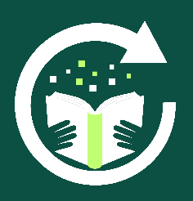

Alternative Provision
Reboot Education
REBUILD - REINTEGRATE - REDISCOVER

Provision Teacher (BSE) Information Pack
April 2026
Dear Applicant

Thank you for your interest in the role of Provision Teacher at Reboot Education – Bury St. Edmunds. In this pack you will find some additional information about the role.

Information about the Role:

Name of Role: | Provision Teacher (Part-Time)
Contract Type: | Permanent
Working Days & Hours: | Thursday to Friday, 9 am to 3 pm, term-time only.
Start Date: | Friday 4th September 2026
Pay Range: | £17,860 to £21,620 (actual salary) per annum per year
Location of Role: | Reboot Education, Unit 6C Park Farm, Bury St. Edmunds, Suffolk. IP28 6TS

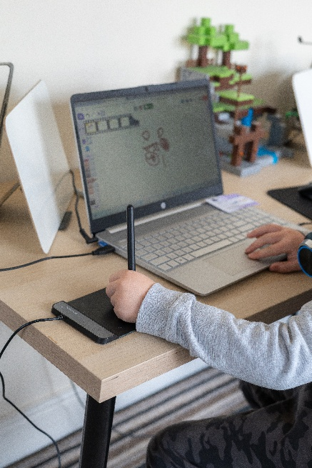
We are looking to recruit a Provision Teacher (part-time), for 2 days a week, (Thursday and Friday). As one of the provision teachers, you will be working with groups of up to 6 students per day, from Key Stages 2 to 4. The main purpose of this role is to re-engage students in their learning and build their self-confidence through the teaching of computer skills, cookery and other areas of the curriculum areas that meet the needs and interest of the students. A typical lesson (learning activity) will last for about 45 minutes.

It is desirable (but not essential) that applicants have some experience of/ or an interest in the computing curriculum from key stages 2 to 4 and experience of teaching across Key Stages 2 to 4.

The main purpose of all roles at Reboot Education is to support students in re-engage in their learning and build their self-confidence through the teaching of computer skills, cookery, core subjects as well as the use of interventions to address areas of need. On a daily basis there will always be 1 teacher on site and 2 Student Support Assistants with a maximum of 6 or 7 students onsite daily.

This role has been created due to increased demands for our service at our Bury St. Edmunds provision, resulting in the need to open our provision from 4 days a week to 5 days a week.

About Reboot Education

Reboot Education was founded by Paul Arch and Viv Hunt. Both Paul and Viv were experienced senior school leaders before setting up Reboot Education. Paul and Viv opened their first alternative education provision in central Ipswich at the start of 2024. Since opening the provision, demand for our service has increased greatly over the last year, which has resulted in Reboot Education opening a second provision in Bury St. Edmunds and moving to a larger base in Ipswich which opened at the start of the Summer Term 2026.
Our provisions are purposefully small and are set up not to feel like a conventional school. We support up to 6 students per day in our Bury Provision and will be able to support up to 12 students at our larger Ipswich provision.

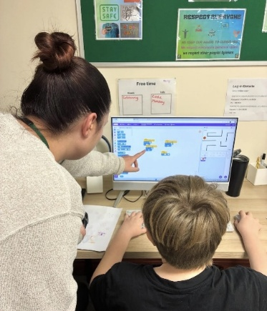
The students who access our provision attend from 1 to 3 days per week and are usually struggling to maintain their mainstream school place. We use a computing and technology-based curriculum to re-engage the students in learning and to help them rediscover their self-esteem and confidence.

Our provision days start at 9.30 am and finish at 2.30 pm. We normally give the students the first 30 minutes of the day to come in and have breakfast and complete a settling task. At 10 am we start the first learning activity of the day, with a break at around 11 am. Following the morning break there is another learning activity and then at 12pm we stop for a lunch break. Between 1pm and 2.00 pm the students complete a final learning activity and then if they have worked hard, they have some reward time before they leave at 2.30 pm.

Why work at Reboot Education:
Since Reboot Education opened, we have grown from a team of 2 to a team of 12 in two years, across our two sites. Our staff retention has been 100% which we believe is down to developing a team that all share and believe in our core values and support each other.
We also offer,
- Competitive rates of pay.
- Employee Assistance Programme.
- Regular training.
- Supportive Senior Leaders.
Working at Reboot has reaffirmed why I chose to become a teacher. Each day provides the opportunity to make a meaningful difference to a young person's life, helping them re-engage with learning and build confidence to recognise their potential.
-Danielle, Provision Teacher, Bury St. Edmunds.



Reboot is a great place to work. We work as a team and support each other, both professionally and personally. Every day is different and we make such a difference to the student’s lives. It’s inspiring to see the progression our students make whilst they have been attending Reboot Education.
-Gemma, Provision Teacher, Ipswich.



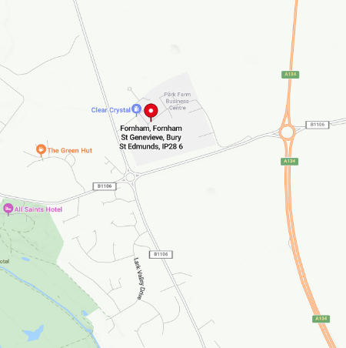
Location of the Role:
This role will be based at our new Bury St. Edmunds base, located in a beautiful setting at Fornham Park, just off the A134. This new provision started taking pupils from the start of September and pupil numbers are building steadily. Within the provision, there is a work area for the students, a small kitchen area and side office. There is also a small grassed outdoor area.

There is plenty of parking for staff and there are also some EV charging stations around Fornham Park, including one at the closest car park to our provision.
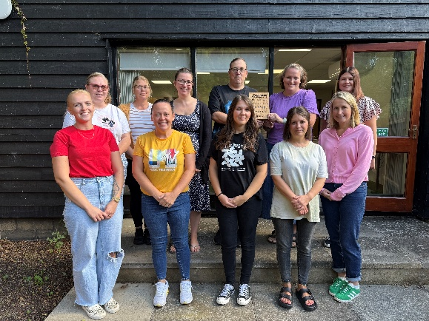
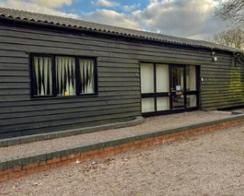

You will need:

Essential: | Desirable:
- Qualified Teacher Status.  - A clear enhanced DBS check.  - A passion for working with young people that have complex needs and some knowledge of SEND.  - Good level ICT skills and ideally experience of teaching computing.  - Be engaging and motivating.  - Be reflective and open to new approaches.  - Good communication skills. | - Have experience of working with students at either Key Stages 2, 3 or 4.  - Experience of working with students with social, emotional and behavioural difficulties.

For more information:
For an informal discussion, please contact Mr Paul Arch or Viv Hunt on (01284) 336635 or by email at hr@reboot-education.co.uk Visits to our provision in Bury St. Edmunds are welcomed. You can also learn more about Reboot Education by visiting our website at www.reboot-education.co.uk

How to apply:
To apply for the role, please download and complete our application form. CVs will not be accepted unless accompanied by our official application form. Completed application to be returned to Reboot Education by email at hr@reboot-education.co.uk or by post to Unit 6C Park Farm, Bury St. Edmunds, Suffolk. IP28 6TS.

Closing Date for Applications: | 4.00pm on Friday 8th May 2026.
Planned Interview Date: | Wednesday 6th May 2026.

