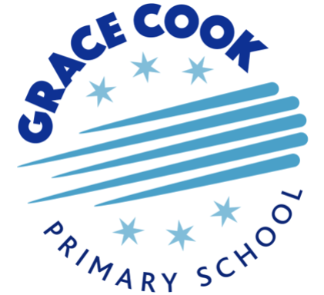

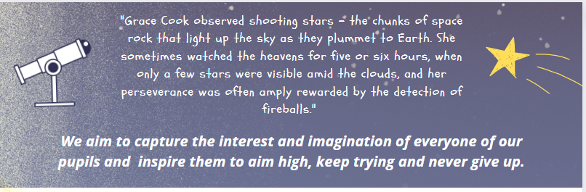
Information about the Grace Cook Primary and Nursery School
Grace Cook Primary School and Nursery opened in September 2022. We are looking for right staff who will have the creativity and energy to help shape and grow the school as part of the Grace Cook team and also enjoy working in collaboration with other Trust Schools

The school was built to serve the growing Northview housing development in the Chilton Leys area of Stowmarket and is initially planned as a 1 form entry primary school. The school first opened its doors with Nursery, Reception, Year 1, and Year 2, and should reach full capacity (EY – Y6) by September 2026. (We currently have children through to Year 4 with 102 pupils on roll in the main school and 72 children in our nursery). The school building has been designed in such a way that it can be readily expanded to a 2-form entry school, should there be the demand for more places in the area in future years.

The 52-place nursery which is run as part of the school currently offers places for 2 - 4 year olds. This was expanded to 2-year-old provision from April 2023 and is organised into two age grouped rooms. The nursery also provides all year-round or term time provision for nursery age children.

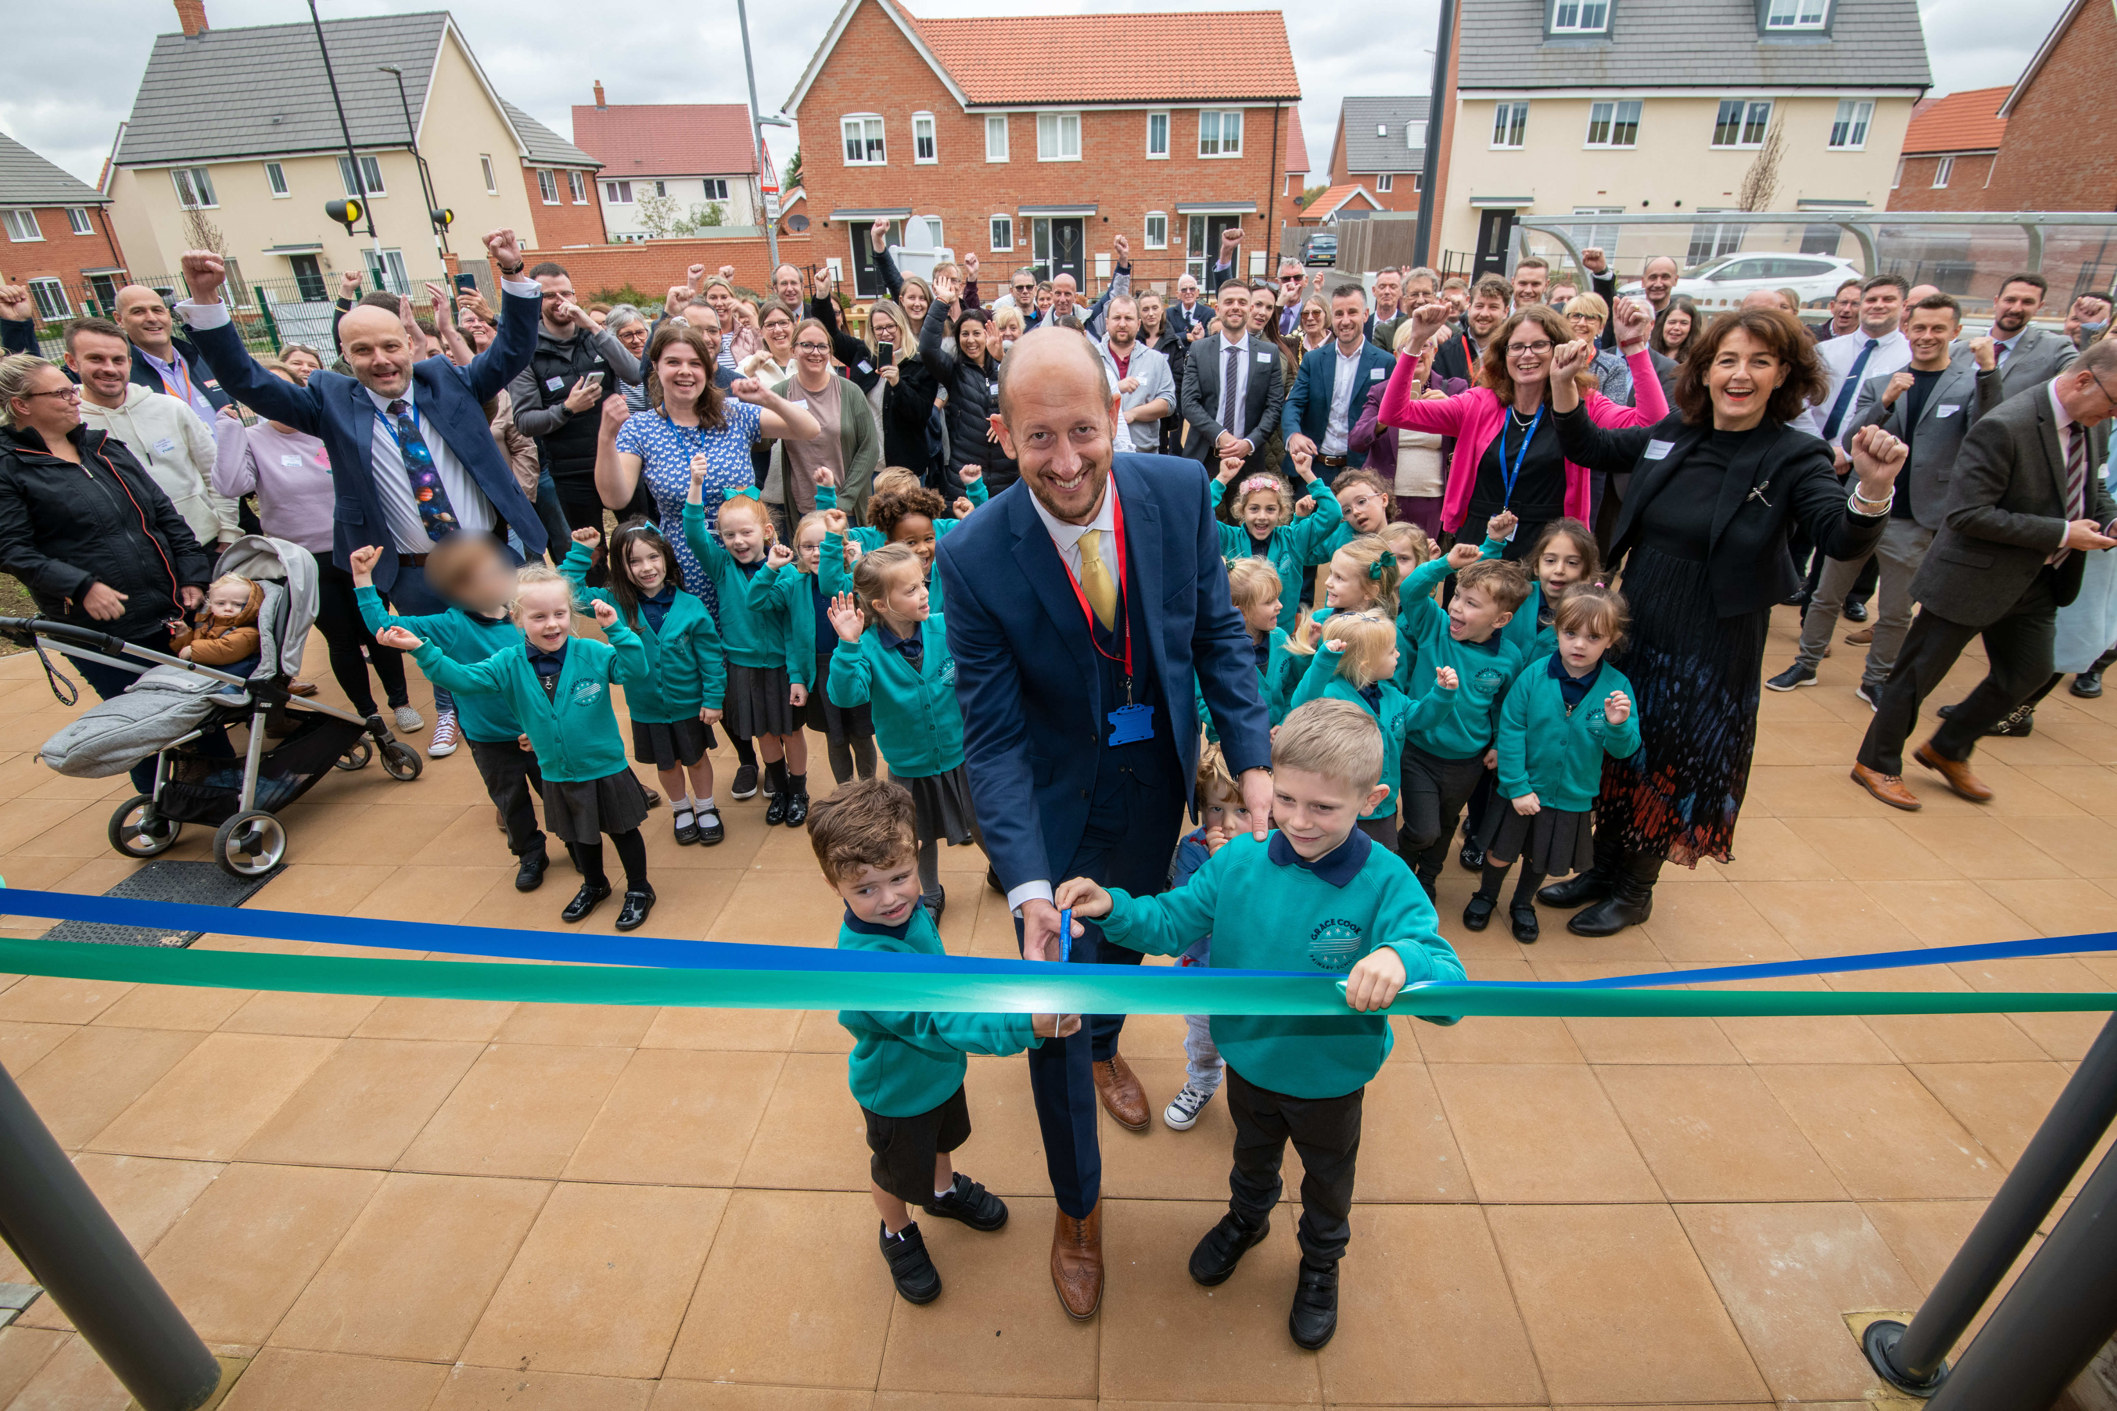

The Early Years and KS1 classrooms are housed on the ground floor of the main school and the separate nursery building is situated within the school grounds.
There are large grounds, including grassed, hard play areas and a ball court.

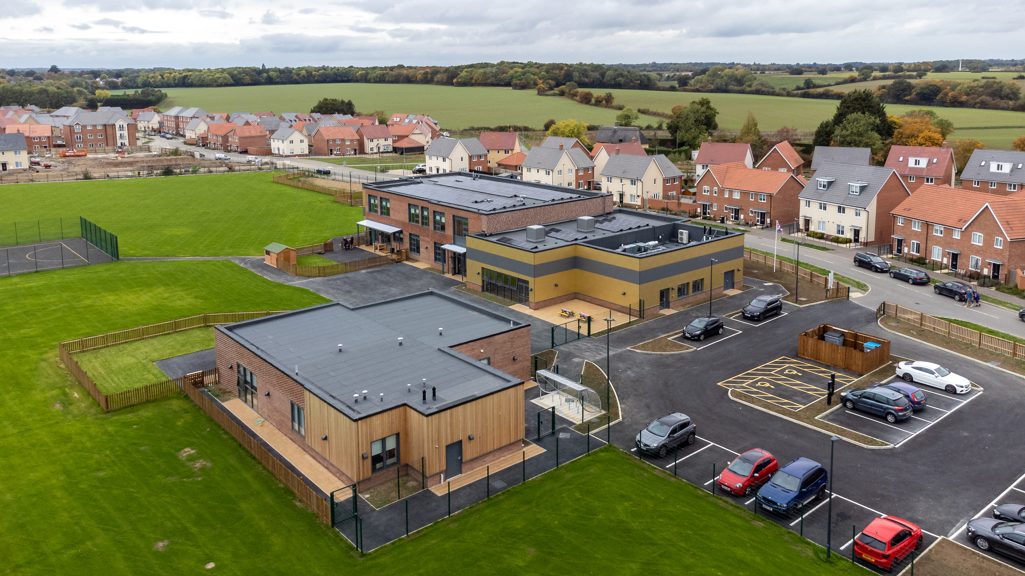

Visits to the school are strongly encouraged. To arrange a visit to discuss the role with our Headteacher, Richard Dedicoat, please contact Laura Ward, who will be happy to help you:
Email – office@gracecook.omat.org.uk telephone – 01449 833094

More information available on the school website – www.gracecook.omat.co.uk and further details about the Trust on www.omat.org.uk

Vision and values of Grace Cook Primary School and Nursery

