





|  |
| --- |
| Applicant Information Booklet |

|  |  |
| --- | --- |
| **Post Title:** | Director of Finance (statutory CFO role) |
| **Salary:** | £75,721 - £86,555 |
| **Contract:** | Full-Time - Permanent |
| **Start Date:** | June 2024 |
| **Responsible to:** | Deputy CEO |
| **Application Deadline:** | Monday 3 March 2025 (midday) |

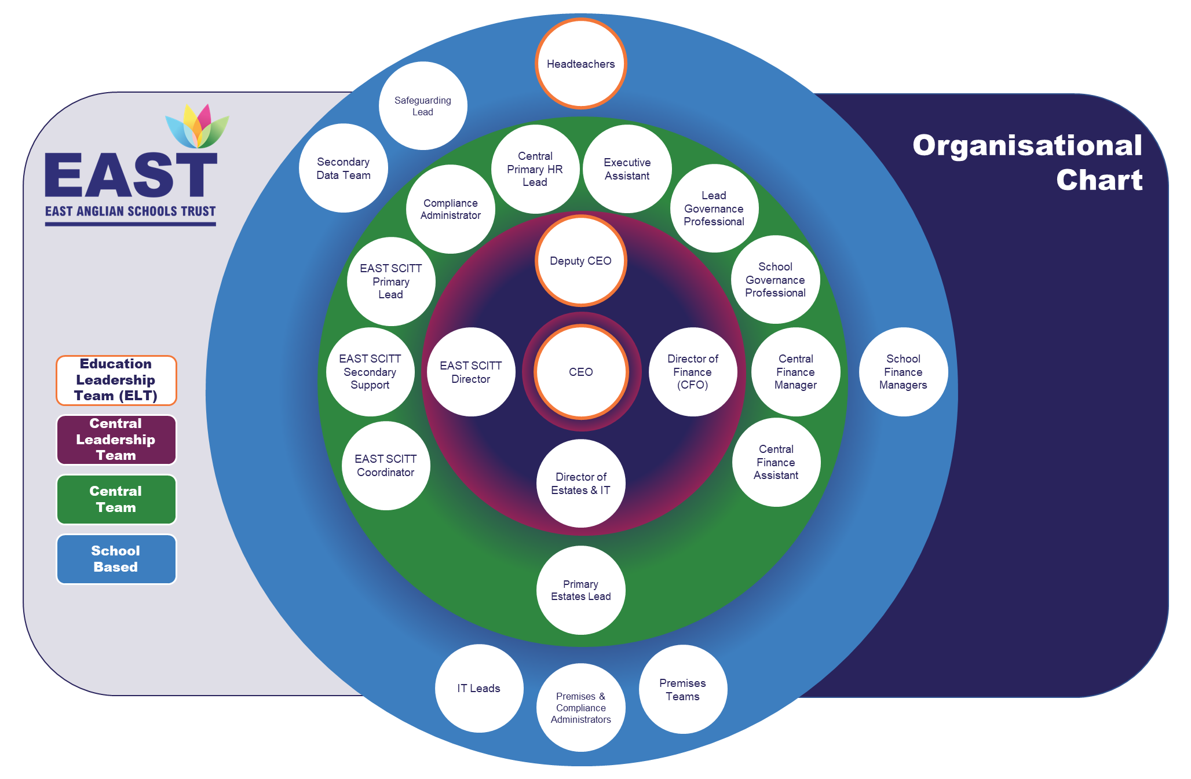

|  |  |  |
| --- | --- | --- |
| Contents | | |
| 1 | Letter from CEO ………..…………………………………………………………………….. | 3 |
| 2 | Advertisement ..……………………………………………………………………………….. | 4 |
| 3 | Job Description ……………………………………………………………………………….. | 6 |
| 4 | Person Specification ..……………………………………………………………………….. | 10 |
| 5 | Organisation Chart …………………………………………………………………………… | 12 |
| 5 | Our Trust ….….……………………………………………………………………………….. | 13 |
| 6 | About EAST .………………………………………………………………………………….. | 13 |
| 7 | EAST Vision ……..……………………………………………………………………………. | 14 |
| 8 | Why you should join EAST ………………………………………………………………….. | 15 |
| 9 | Governance .....……………………………………………………………………………….. | 17 |

Letter from CEO

Dear Applicant,

Thank you for your interest in the post of Director of Finance for the East Anglian Schools’ Trust.

We are looking to appoint an inspirational professional to lead the financial business of the Trust. The Director of Finance will fulfil the Chief Financial Officer (CFO) role as required by the Education and Skills Funding Agency (Department for Education from March 2025) with overall strategic responsibility for financial management, providing technical leadership and support in all accounting matters across the Trust. The Director of Finance is a key appointment for EAST. You will be an approachable and enthusiastic individual with a strong understanding of how effective financial and business leadership is essential for a multi-academy trust.

The Trust currently has nine Suffolk schools and a school-centred Initial Trainee Teacher Provider. By September, 2024, this will have increased to eleven with an aspiration for continued, sensible growth which enhances the quality of educational collaboration, expertise and infrastructure for our schools. We are determined to deliver the best educational experience for students. EAST’s schools are approximately within a 1 hour drive between sites.

We have excellent, comprehensive schools across all phases, and a reflective culture that places our four cornerstones of learning, inclusivity, opportunity and community at our foundations. We are extremely proud of our progressive and growing trust. Each school is unique in context and in character but they all share an educational vision which celebrates achievement and diversity, inspiring young people to contribute to society and make a difference.

We hope we have provided you with the details you require to build a good understanding of the advertised role. Should you wish to discuss the post further, we would welcome an informal conversation. Please do not hesitate to contact our Trust HR Manager, Melissa Rodwell on [mrodwell@eastmat.org](mailto:mrodwell@eastmat.org) or 01728 746504 option 4 who will arrange this with Cheryl Singleton (Deputy CEO) or me.

We look forward to hearing from you.

Yours sincerely

Angelo Goduti

**Chief Executive Officer**

Advertisement

Director of Finance (statutory Chief Financial Officer)

|  |  |
| --- | --- |
| **Central Trust Office:** | Wickham Market Primary School |
| **Salary:** | £75,721 - £86,555 |
| **Hours:** | Full Time, 52 weeks per year |
| **Contract Status:** | Permanent |
| **Reports to:** | Deputy Chief Executive Officer |

The East Anglian Schools’ Trust (EAST) has an exciting opportunity to join our forward-thinking and growing Trust as we seek to appoint to the post of Director of Finance. We are looking to appoint an inspirational professional to lead the financial business across EAST. With excellent, comprehensive schools across all phases, and a reflective culture that places our four cornerstones of learning, inclusivity, opportunity and community at our foundations, we are extremely proud of our progressive Trust.

The Director of Finance is a key appointment for EAST and will fulfil the Chief Financial Officer (CFO) role as required by the Education and Skills Funding Agency (Department for Education from March 2025), with overall strategic responsibility for financial management, providing technical leadership and support in all accounting matters across the whole Trust.

The successful applicant will be a dynamic individual who understands what constitutes effective and high quality leadership. They will be approachable and enthusiastic with a strong understanding of how effective financial and business leadership is essential for a multi-academy trust. The ability to work with other leaders to ensure that expertise is valued and utilised across EAST will be essential. We will be keen to explore with how driven applicants are to improve educational outcomes and life chances for young people through this crucial role. Our future Director of Finance will have a proven record of strategic leadership and people management, along with the ability to drive improvements.

This role presents many opportunities for an ambitious, experienced professional to lead and shape a wide range of services across our schools, as well as to contributing to the development of the wider organisation and our growth.

Although not limited to these sectors, we would welcome applicants who come from a commercial, corporate, or educational background. It is essential that applicants have a resonance with our vision alongside relevant expertise and experience. The ability to be diligent, have a ‘can-do’ mind-set and shape systems to drive quality for our Trust/Schools is essential. Working collaboratively and translating vision and strategy into operational requirements are fundamental to the role.

This is a role that is based at our central office in Wickham Market Primary School, Suffolk, but will require the post holder to move between schools as needed. EAST is committed to the care and professional development of all individuals who work in our schools and Trust. A compassionate approach to all individuals is expected of our Trust’s employees.

Should you wish to discuss the post further, we would welcome an informal conversation. Please do not hesitate to contact our Trust HR Manager, Melissa Rodwell on [mrodwell@eastmat.org](mailto:mrodwell@eastmat.org) or 01728 746504 option 4 who will arrange this with Angelo Goduti (CEO) or Cheryl Singleton (Deputy CEO).

Applications should use the EAST application form. CVs will not be accepted. Letters of application should outline your vision, experience and expertise in relation to the role and be no longer that two sides of A4, addressed to Angelo Goduti (CEO). Please email applications to Melissa Rodwell on [mrodwell@eastmat.org](mailto:mrodwell@eastmat.org)

Deadline for applications: Monday 3 March 2025 (midday)

Please visit our website for further details about EAST: https://www.eastmat.org/

*EAST is committed to safeguarding and promoting the welfare of children, young people and vulnerable adults and expects all staff and volunteers to share and adhere to this commitment. DBS checks required for all posts.*



**Director of Finance**

**Job Description**

Overall Responsibilities 

The Director of Finance will fulfil the Chief Financial Officer (CFO) role as required by the Education and Skills Funding Agency (Department for Education from March 2025) with overall strategic responsibility for financial management, providing technical leadership and support in all accounting matters across the whole Trust. They will fully support the Trust’s educational and business-related priorities.

The duties listed in the job description are not intended to be an exhaustive list but are the general guidelines to the post, and other duties expected of a senior executive leader may be undertaken by the post holder. Tasks are not excluded from the post simply because they are not itemised. We require all staff to be flexible in their approach in supporting the Trust and its schools

All duties undertaken must be carried out in accordance with relevant Trust / school policies and procedures, within legislation, and with full regard for the needs of our school communities.

Safeguarding

The Trust is strongly committed to safeguarding and promoting the welfare of children and young people. The successful applicant shall be required to undertake an enhanced DBS disclosure and other safer recruitment checks.

Tasks

**Strategic Leadership**

* Lead the Trust’s financial strategy, including preparing the annual budget and medium-term plan
* Work closely with Executive Leaders and Trustees to ensure delivery of Trust’s strategic and financial objectives, and providing assurance that the Trust can remain a going concern
* Provide financial leadership to the strategic planning process and contribute to the Trust Development Plan
* Be actively involved in, and add strategic value to all material business decisions to ensure immediate and long-term implications, opportunities and risks are fully considered, and align with the Trust’s financial strategy
* Provide advice and guidance to the CEO, DCEO and Executive Leaders, and Trustees
* Proactively manage cash reserves to maximise investment.
* Lead the Trust’s procurement strategy and policies (including overseeing tendering process) and how this translates into effective and efficient operation activity to achieve financial efficiencies,
* Monitor the financial performance of the academies regularly and systematically, and report outcomes to the CEO, DCEO and the Trust Board/Committees
* Be responsible for supporting a robust a capital strategy for the trust, managing capital funds and securing capital funding through and other bids

**Finance Compliance**

* Complete and submit financial returns as required by the Department for Education, the Education and Skills Funding Agency, the Charities Commission and Companies House
* Prepare and submit the Trust’s financial returns and reports, including annual accounts and monthly management accounts, and the completion of returns to other, relevant external agencies
* Provide appropriate and timely reports to the Trust Board, Committees and other Trust leaders to support effective leadership and governance
* Maintain Trust accounts in accordance with the Funding Agreement, Academies Trust Handbook and Accounts Direction issued by the funding body, and in accordance with the financial regulations and procedures of the Trust
* Ensure the Trust follows best practice in terms of financial governance
* Ensure the probity, and legislative compliance of all financial transactions, including payroll and cash handling, and the integrity and suitability of all control mechanisms
* Lead the internal scrutiny processes with the CEO and DCEO and follow up on any resulting recommendations
* Lead external audit, preparing and submitting audited statutory consolidated accounts to the ESFA (Department for Education, March 2025) and Companies House in accordance with required deadlines and follow up on any resulting recommendations
* Ensure effective financial structures and controls support robust financial management
* Lead on the construction, implementation and evaluation of delegated policies and procedures
* Maintain the relevant aspects of the Trust’s Risk Register

Ensure that the Trust is compliant with the requirements of:

* Education and Skills Funding Agency (until it ceases and is replace by the DfE in March 2025)
* Charities Commission
* Companies Act
* HMRC for PAYE and VAT
* Pension Regulator
* Trust’s Finance Policy and Procedures and best practice
* Other regulatory / Government requirements

**Financial Health & Financial Risk Management**

The Director of Finance will be accountable for maintaining robust financial management of the trust and its academies:

* Manage the budget process, from planning through to approval, working with other Trust leaders
* Work with Headteachers to prepare and monitor school budgets in line with school development plans and the Trust’s strategic objectives
* Provide accurate and timely information to the Board and other Trust leaders to enable effective budgetary control
* Liaise with Local Authority finance officers and Trust leaders/SEND administrators to identify pupil funding and oversee systems to ensure that full funding is properly recouped (including specialist grants from the DfE/ESFA, etc.)
* Take appropriate action to address financial risks, problems and irregularities
* Advise the Board and Trust leaders on the development and maintenance of an effective internal audit procedure for the trust and its academies, including producing audit reports and making recommendations for improvement
* Oversee the Trust’s commercial contracts with the Director of Estates and IT, ensuring they represent value for money
* Support Director of Estates and IT with insurance arrangements for the Trust
* Be responsible for the Trust bank accounts and manage administration and the trust’s cash position, including overseeing bank deposits
* Support the income generation strategy for the trust and its academies

**Audit & Annual Accounts**

* Manage the provision of all information required by the external and internal auditors for audit / internal audit of the Trust’s accounts, annual report and Teachers’ Pensions End of Year Certificate
* Ensure grants meeting DfE audit assurance threshold are audited

**Leadership, Financial Advice & Guidance**

The Director of Finance will be accountable for supporting the effective management of the Trust and its academies, and for providing motivational leadership at all levels of the Trust’s organisation:

* Take responsibility for the Trust’s financial management system including managing user access, providing training, considering future system developments and generating reports
* Manage the whole Trust Finance Team, taking responsibility for their performance and professional development, ensuring best practice is observed at all times
* Develop the Trust’s central finance services, ensuring these are fit for purpose and provide a high-quality service to academies/services/provisions, helping the Trust achieve continuous improvement
* Develop effective relationships with the Trust’s stakeholders and partners to support its development and operations
* Update and disseminate the Trust’s financial policies and guidance
* Attend and advise Trust Board, Finance and HR and Audit and Risk Committees
* Quality assure Trust wide strategic supplier relationships with the Director of Estates and IT
* Provide effective introduction / integration of financial systems and processes in schools joining the Trust and for existing schools

**Payroll & Pensions**

* Work with the DCEO and HR colleagues to support the effective delivery of payroll services for the Trust and its academies/services/provisions
* Monitor and appoint payroll provider
* Oversee payment of employer’s pension contributions for teachers and support staff
* Ensure payroll files are reconciled to the accounts system

**Procurement**

* Lead on financial aspects of procurement and processes
* Maintain proactive contracts register with the Director of Estates and IT

**Taxation**

Manage the Trust’s tax and National Insurance arrangements, including ensuring claims for VAT and business rates are submitted and refunds are received and appropriately accounted for

* Submit monthly VAT returns
* Submit Gift Aid returns
* Ensure PAYE is submitted

**Systems Administration & Financial Control**

* To maximise efficiencies and streamline processes across finance operations
* To ensure the operating model is scalable and can support successful induction of new schools without compromising core purpose
* Developing and maintaining financial systems to ensure income collection procedures are operating effectively, and debt problems are minimised invoices are processed efficiently
* Proactively managing the relationship with its bankers, to ensure that appropriate and efficient systems are in place for the Trust’s accounting procedures
* Planning and co-ordinating all tax and treasury management practice and policy, with reference to charitable status and cash management
* Ensure that the Trust achieves value for money across all its activities, including the delivery of services

**Growth & Development**

* Work with the CEO and DCEO to identify opportunities for growth
* Conduct financial due diligence on schools applying to join the Trust, and report to the Board and other Trust leaders with recommendations
* Lead on the conversion process across finance and legal functions
* Act as a representative and champion for the Trust in external networks and forums, raising the profile of the Trust, engaging with the wider sector, and ensuring that the trust is alert to information, changes and opportunities that could affect its work

**Equality & Diversity**

* Support, recruit, manage, develop and motivate a committed, effective and diverse workforce that understands its roles and enables and promotes high quality learning

**Other Duties**

* Contribute to the overall aims and ethos of EAST
* Work in a professional manner and with integrity, maintaining confidentiality of information
* Maintain up-to-date knowledge in line with changes to legislation as appropriate to the role
* Participate in training and other learning activities and performance development as required
* Maintain consistently high standards of professional conduct, tact and diplomacy always in dealing with students, parents, staff and colleagues, external agencies etc.
* Abide by the Trust’s policies and Code of Conduct

Review

* The job specification details the main outcomes required and should only be updated to reflect major changes that impact on the outcomes for the job
* This job description will be reviewed periodically and may be subject to amendment or modification at any time after consultation with the post-holder

Person Specification

|  |  |  |
| --- | --- | --- |
| **Area** | **Essential** | **Desirable** |
| **Qualifications** | | |
| Qualified to degree level. |  | ü |
| Professional finance or finance related qualification at graduate level (i.e. ACA, ACCA, CIMA, CIPFA, MAAT or equivalent). | ü |  |
| **Knowledge, Understanding & Experience** | | |
| Significant post qualifying experience and in-depth professional knowledge acquired through experience. | ü |  |
| Experience managing significant financial resources with a good appreciation of relevant regulatory frameworks. | ü |  |
| Familiarity of financial processes and procedures. | ü |  |
| Experience of effectively managing a team. | ü |  |
| In depth knowledge of statutory requirements, procedures and regulatory requirements relating to academies. |  | ü |
| High level of IT competence, literacy and numeracy skills. | ü |  |
| Experience of using and supporting others in the use of  financial software packages, including a working knowledge of PS Financials and IMP Budgeting software. |  | ü |
| Experience in working in a similar role and environment. |  | ü |
| Experience of managing staff. | ü |  |
| Experience of managing budgets. | ü |  |
| Experience of communication with colleague and external professionals at all levels of the organisation and the ability to negotiate and act on behalf of the Trust in relation to contracts and contract detail. | ü |  |
| Experience in contract management. | ü |  |
| Knowledge and experience of obtaining and managing grant funding. |  | ü |
| **Personal & Professional Qualities** | | |
| Strong, persuasive, influencing and interpersonal skills with the ability to communicate clearly and confidently. | ü |  |
| Excellent skills in strategic planning and strategic management of financial resources. | ü |  |
| Clear analytical skills to allow the exploration evaluation and interpretation of information and opinions and utilisation of management information systems. | ü |  |
| Strong decision making skills with the ability to make decisions and recommendations based on the analysis of options. | ü |  |
| Capacity to work under pressure to meet deadlines and organisational priorities. | ü |  |
| Good leadership skills and ability  to inspire and challenge colleagues. | ü |  |
| Commitment to staff and own personal development. | ü |  |
| Flexible in terms of working patterns and evolution of the role. | ü |  |
| Team-player, personable, emotionally intelligent with a sense of humour. | ü |  |
| Capable of multitasking, problem solving and delivering to deadlines. | ü |  |
| Receptive to new ideas and able to generate them. | ü |  |
| **Other** | | |
| Driving licence and own transport. | ü |  |

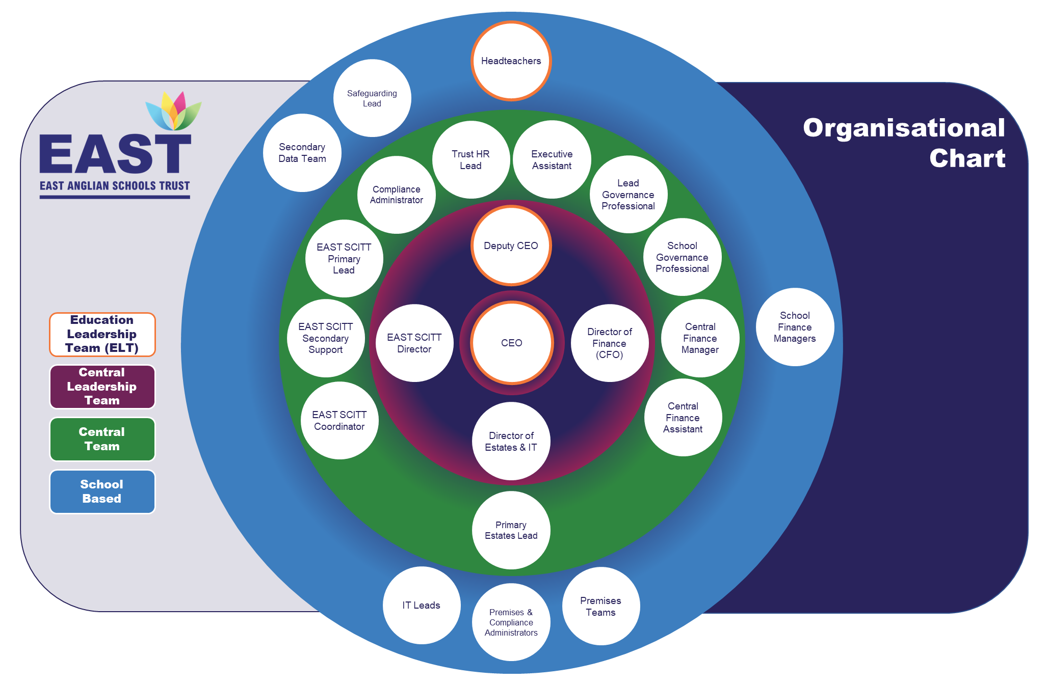Organisational Chart

Please note, this is currently under review.

Our Trust:

About EAST:

For further information about EAST please view details from our 2024 AGM: <https://www.eastmat.org/Annual-Governance-Meeting-s-AGM/>





EAST Vision

Our **cornerstones** are the foundations of our vision; they underpin all that we do and shape the way we work with everyone in our Trust and our extended educational community; from parents & carers to partners, suppliers and local government.

Our Vision: Where everyone can achieve

Our vision has been created collectively and represents our shared aims. It is summarised in a simple yet powerful statement, ‘…where everyone can achieve…’ reflecting our ambitious approach to education.

We measure our **success** as individuals and collectively through a combination of three underpinning goals:

**Performance**

**Growth**

**Happiness**

Why you should join EAST



**#3 Opportunity**

We exist to enable everyone in our schools to realise their true potential through an academic or professional experience within our schools that achieves the outcomes they seek. We do not believe there is a one-size-fits-all for success and achievement and will always do our best to support the aims and ambition of the individual.



**#1 Learning**

We will continually strive to deliver the best possible experience for quality learning and personal development for everyone at EAST through our curriculum, engaging teaching, the resources & support we have available and the quality of the physical environment in which we work.



**#2 Inclusivity**

We believe a great quality education, opportunities for personal development and participation should be available to everyone regardless of their personal circumstances. That’s why our schools today already cater for many specialist needs and our Trust is committed to developing the teachers of the future.



**#4 Community**

We are a significant contributor to our local communities, we understand the role we play and will always seek to enable everyone at EAST to be considered, active, positive citizens of the world around them. Our sense of community begins in our schools and we nurture a respectful, supportive culture.

|  |  |
| --- | --- |
| **Benefits of working for an EAST school**  EAST is driven to improve the working lives of its staff. We endeavour to always acknowledge the contributions made by our staff, and strive to make everyone know that they are a valued member of the team. EAST aims to do this in a variety of ways including, providing a healthy working environment, training and development opportunities and ensuring that staff at all levels feel part of the team by means of excellent communication.  **Health & Well-being**  **Promoting Equality and Diversity**  A key area in EAST’s vision is ‘Inclusivity’ and this is paramount for both students and staff. Our philosophy is to create an environment “where everyone can achieve”. Whether you are a student or a staff member, you will have many opportunities for personal and professional development. Staff work within a collaborative environment and we all support each other.  **Support Services**  As a member of the EAST team, you will have the ability to access a wide range of resources to help manage your wellbeing. The Employee Assistance Scheme is completely confidential and very discrete, offering counselling sessions, advice on financial management and access to medical advice. | **Employment Package**  **Pension Schemes**  Our Teaching and Support Staff within our schools and central team are offered an excellent pension package. For teachers, it is the Teachers’ Pension Scheme, and for Support Staff, it is the recognised Local Government Pension Scheme (LGPS).  **C:\Users\User\AppData\Local\Microsoft\Windows\INetCache\Content.Word\277A0593.jpg**  **Maternity / Paternity / Shared Leave**  We operate a ‘Keep in Touch’ scheme, to help with those transitioning into a period of leave, or back to work. Maternity, Paternity and Shared Leave is fully supported.  **Car Parking Facilities**  The central office, and all our schools have the benefit of being able to offer free car parking to all staff and visitors. |

|  |  |
| --- | --- |
| **Career Development:**  **Education, Training and Development**  We are proud to offer all members of staff the training they require to succeed in their roles, and accomplish their very best. Performance, Growth and Learning are all key areas within the Trust’s vision, and underpin the Trust’s aspirations for both staff and students.  C:\Users\User\AppData\Local\Microsoft\Windows\INetCache\Content.Word\history classroom.jpg  **Early Career Teachers (ECTs) and Initial Trainee Teachers (ITTs)**  EAST works alongside the Ambition Institute to ensure our ECTs are offered an extremely supportive programme. ECTs are given support to ensure that they develop the necessary skills to become excellent teachers. As well as this, we are very proud that EAST SCITT is a part of our organisation. EAST SCITT is an ITT Provider ‘developing teachers of the future’ for our schools and the local area. By having EAST SCITT as part of our organisation we are in an excellent position to know what ECTs need when they first become qualified. | **Support Services:**  **IT Services & Resources**  All staff members have access to a dedicated IT Support Team who are always happy to help. We are very aware that the work our employees do is crucial, and it is essential that the relevant equipment and technology is in place so that our staff can work efficiently to support students.  **Trade Union**  The work of Trade Unions is fully recognised by our schools for both Teaching and Support Staff. The Trust and its schools work closely and collaboratively to ensure staff are fully supported.  13 |

Governance

Governance of EAST is strong and principled, undertaken by Governors in each school (Local Governing Bodies - LGBs), a Trust Board working across the MAT and an overarching Members Board. The collective knowledge, skills, experience and insight of all these individuals ensures that Governance in our Trust both challenges and supports each school to ensure the best outcome for our learners. Our Board ensures that EAST complies with charity and company law requirements. In accordance with Academy requirements, the Trust follows approved Articles of Association with a clear and robust Scheme of Delegation.

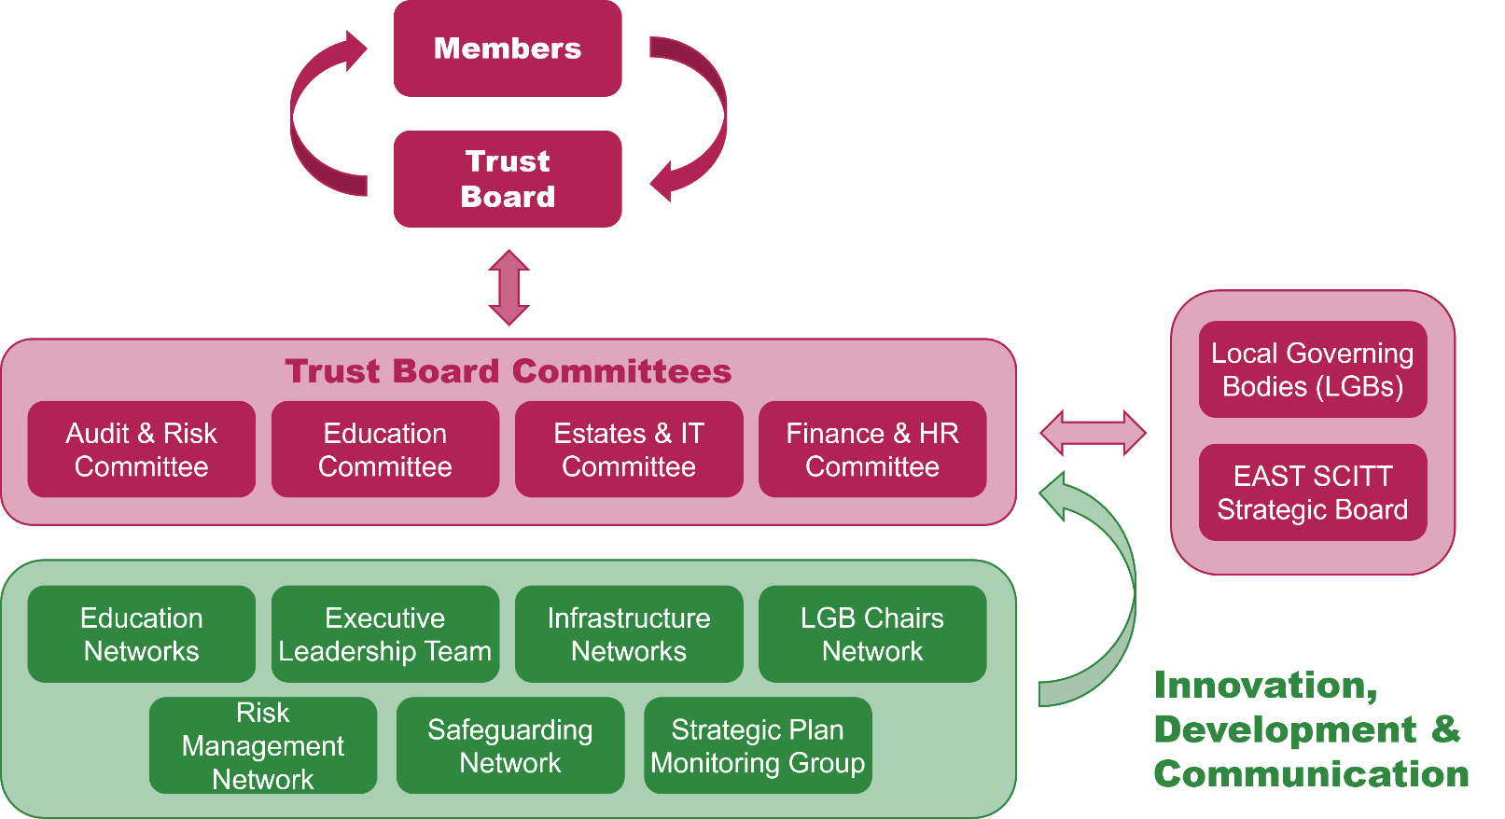

Please refer to our website for further information relating to the governance structure of EAST.