

Teacher Information Pack
REBUILD - REINTEGRATE - REDISCOVER

January 2026

Dear Applicant

Thank you for your interest in the role of teacher at Reboot Education – Bury St. Edmunds. In this pack you will find some additional information about the role.

The Role
We are looking to recruit a part-time teacher for 2 days a week, on a Thursday and Friday. As one of the provision teachers, you will be working with groups of up to 6 students per day, from Key Stages 2 to 4. The main purpose of this role is to re-engage students in their learning and build their self-confidence through the teaching of computer skills. A typical lesson (learning activity) will last for about 45 minutes.
Working Hours: 9 am to 3 pm, 2 days per week.
Pay range: £17,860 to £21,620 (actual salary) per annum per year. * As an independent provision, can’t contribute to the Teacher’s Pension Scheme, but we provide staff with a suitable pension.
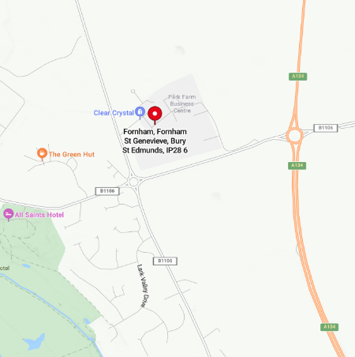
Location of the Role:
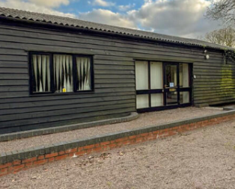
This role will be based at our new Bury St. Edmunds base, located in a beautiful setting at Fornham Park, just off the A134. This new provision started taking pupils from the start of September and pupil numbers are building steadily. Within the provision, there is a work area for the students, a small kitchen area and side office. There is also a small grassed outdoor area.

There is plenty of parking for staff and there are also some EV charging stations around Fornham Park, including one at the closest car park to our provision.

About Reboot Education

Reboot Education was founded by Paul Arch and Viv Hunt. Both Paul and Viv were experienced senior school leaders before setting up Reboot Education. Paul and Viv opened their first alternative education provision in central Ipswich at the start of 2024. Since opening the provision, demand for our service has increased greatly over the last year, which has resulted in Reboot Education opening a second provision in Bury St. Edmunds. The Bury St. Edmunds base opened in September 2025 for 3 days a week. Now due to increased demand for our service, we are looking to open for 5 days a week.
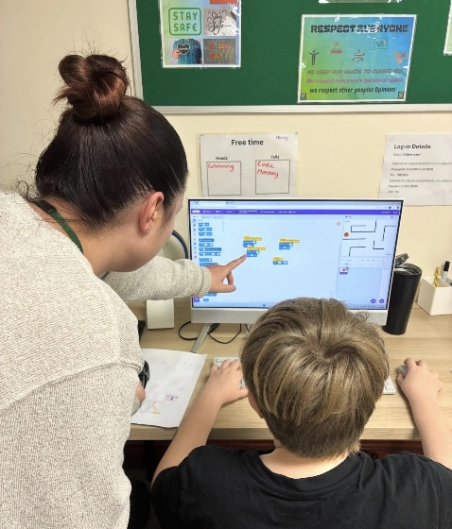
Our provisions are purposefully small and are set up not to feel like a conventional school. We support up to 6 students per day. The students who attend our provision attend from 1 to 3 days per week and are usually struggling to maintain their mainstream school place. We use a computing and technology-based curriculum to re-engage the students in learning and to help them rediscover their self-esteem and confidence. This is a real opportunity to make a difference to the lives of students who are often most in need of people to believe in them. Each provision is staffed with at least 1 teacher and 2 members of support staff daily.

Our provision days start at 9.30 am and finish at 2.30 pm. We normally give the students the first 30 minutes of the day to come in and have breakfast and complete a settling task. At 10 am we start the first learning activity of the day, with a break at around 11 am. Following the morning break there is another learning activity and then at 12pm we stop for a lunch break. Between 1pm and 1.45pm the students complete a final learning activity and then if they have worked hard, they have some reward time.

You will need:
- Qualified Teacher Status.
- A passion for working with young people that have complex needs and some knowledge of SEND.
- Have experience of working with students at either Key Stages 2, 3 or 4.
- Experience of working with students with social, emotional and behavioural difficulties,
- A good level ICT skills and ideally experience of teaching computing.
- To successfully pass an enhanced DBS check with no disclosures on it.

For more information:
For an informal discussion, please contact Mr Paul Arch or Viv Hunt on (01284) 336635 or by email at office@reboot-education.co.uk. Visits to our provision in Bury St. Edmunds are welcome to find out more about Reboot Education. You can also learn more about Reboot Education by visiting our website at www.Reboot-education.co.uk

How to apply:
To apply for the role, please download and complete our application form. CVs will not be accepted unless accompanied by our official application form.
Completed application to be returned to Reboot Education by email at office@reboot-education.co.uk or by post to Unit 6C, Park Farm, Fornham St Genevieve, Bury St. Edmunds, Suffolk. IP28 6TS.

Closing date: 4.00pm on Friday 13th February 2026.
Interview date: To be confirmed but will take place between Monday 16th and Friday 20th February.

