Job Description
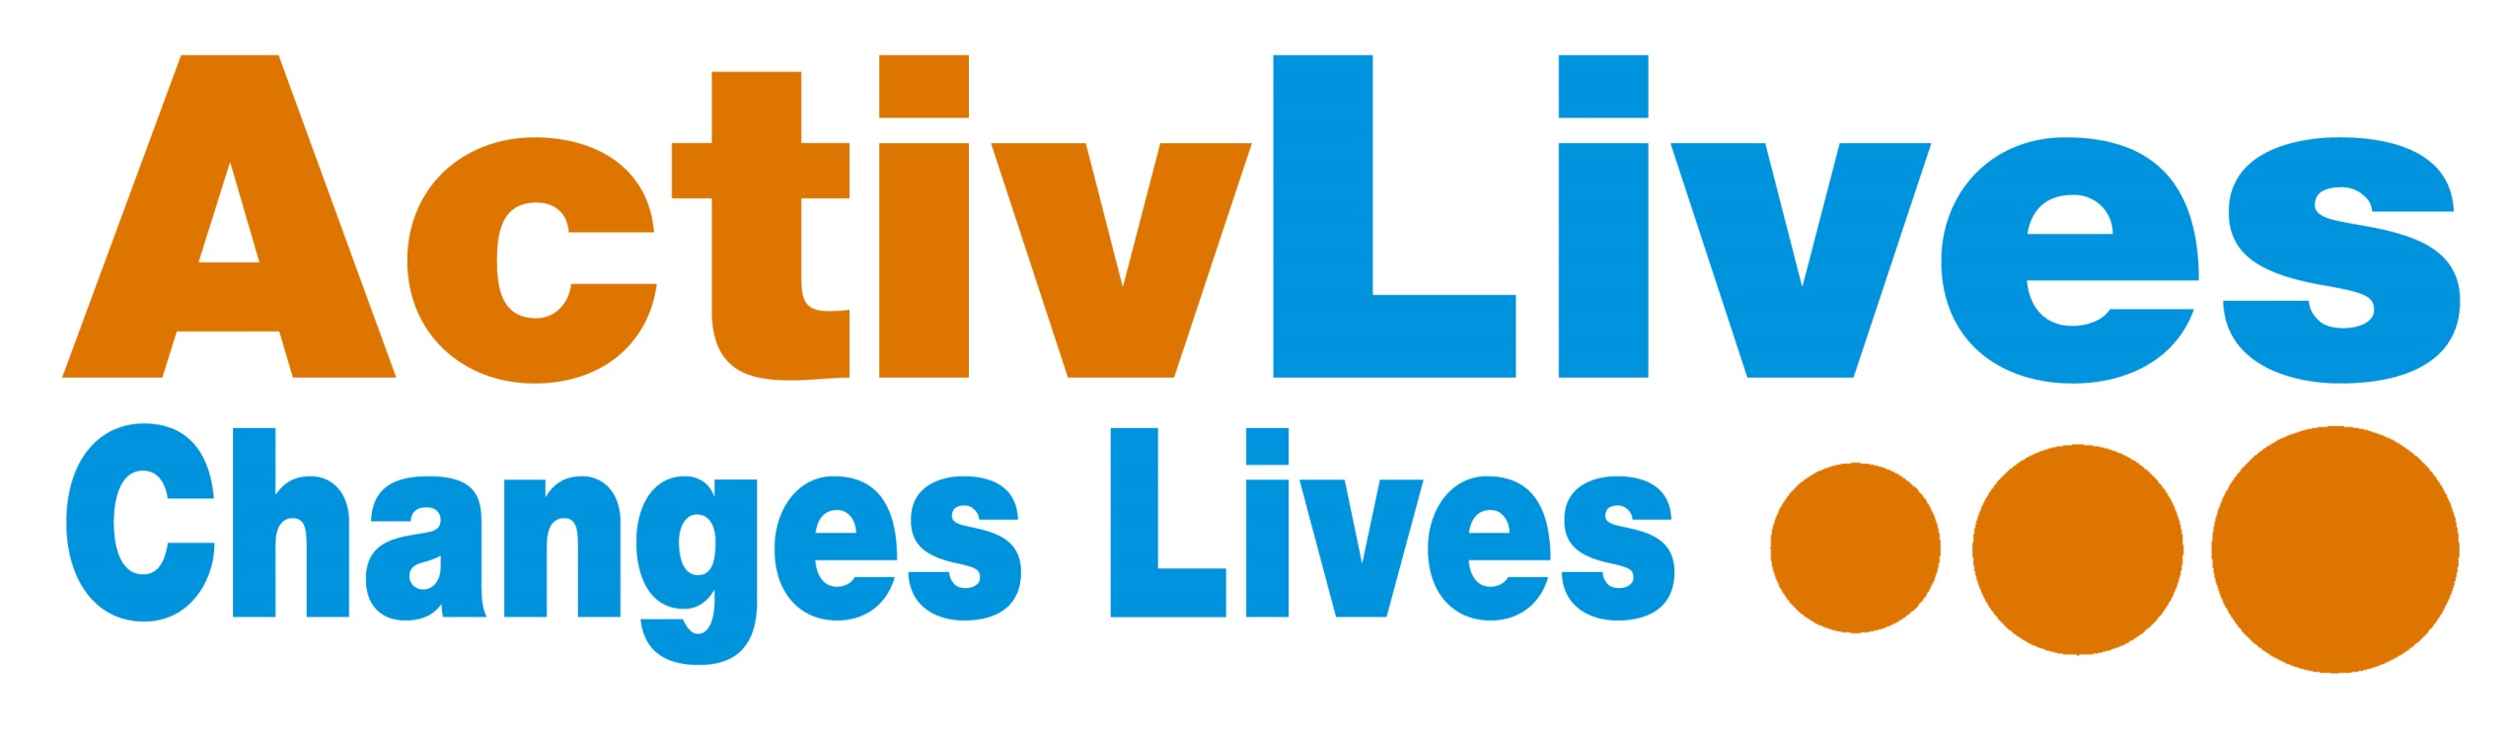
Job Title: ActivSport Development Co-ordinator Hours: 22.5 hours per week

Reporting to: CEO Base: Ipswich and East Suffolk

Job Purpose

To engage with local communities and other agencies across Ipswich and East Suffolk to proactively promote the ActivLives – ActivSport Programme and brand, aimed at older independent adults. To oversee, deliver and develop existing ActivSport activities, exploring new developments and funding and achieve all project outcomes through effective use of resource. To inspire, engage and recruit people to volunteer to support activities and to motive others to join.

To contribute to the achievement of the ActivLives vision; “To create stronger, healthier communities, reduce health inequalities and provide new learning to enable people to live full and active lives.”

Areas of Responsibility
Project Management
- Responsible for the successful delivery and development of inclusive sport and physical activity sessions in the Ipswich and East Suffolk area for people aged 55 years and over
- Oversee the development and/or delivery of existing activity sessions, such as ActivBowls, ActivKurling, ActivBoccia, Ping Pong, Short Tennis, Walking Football, Health Walks etc
- Assist with taster sessions / talks to showcase activities, and where there is sufficient demand, follow these up by establishing new on-going regular sessions.
- Seek out appropriate community venues, suitable for the type of activity, ensuring that they are accessible. Agree the use of the premises, costs involved, and ensure the relevant policies and procedures are in place and risk assessments completed
- Support existing qualified freelance activity instructors to continue to provide high standards and beneficial programmes to improve the health and well-being of people living in Ipswich and East Suffolk
- To maintain clear and concise records as necessary and help produce quarterly and annual reports
- Develop good working relationships with partner organisations and promote projects and the organisation at any meetings / events you may attend
Business Development and Promotion
- Develop existing sessions to attract new members, helping to ensure the longer term financial viability of the sessions
- Explore new opportunities to support the development and sustainability of the ActivSport Programme
- Be an ambassador of ActivLives, working closely with key partners and proactively promoting and increasing the awareness of the ActivLives brand and its projects
- Contribute ideas / suggestions to develop the ActivSport Programme and provide the CEO with information / data / case studies etc for funding bids as and when required

People Management
- Support and cover sessional freelance staff as required, ensuring good two-way communication and information
- As and when required, recruit volunteers to help support activity sessions with tasks such as taking the register and collecting money, making teas and coffees, and supporting participants who need help during the session
- Support sessional staff and volunteers, and ensure that they are aware of ActivLives key Policies & Procedures, Health & Safety etc and assist the CEO in co-ordinating any training required to enable them to perform at the highest level and achieve their full potential
- Lead by example by demonstrating exceptional customer service, and promote a fun working environment, where freelance instructors and volunteers feel valued

Health and Safety
- Responsible for the Health and Safety of ActivSport sessions and being aware of Health and Safety policies and procedures and Accident Reporting
- Ensure that risk assessments are completed for each community venue and safe working practices are being followed
- Ensure that all equipment used is in working order and the surrounding environment is safe
- Keep up to date with Health & Safety regulations, particularly in the area of sport / activity

Personal Development
- To be fully conversant with policies including Equal Opportunities and Diversity, Children, Young People and Adults at Risk Safeguarding Policies, Health and Safety, First Aid and Volunteering
- To undertake relevant continuing professional development training in order to fulfil the duties of your post and to further develop the ActivSport sessions.
- Effectively contribute at Team Meetings / Development Workshops and the achievement of the ActivLives vision

Person Specification
Qualifications
- Level 3 or 4 in Physical Activity in the Community / Fitness / Coaching / Sports
- Qualifications / experience in working with older people or Adults at Risk of Harm

Experience
- At least two years sport and/or physical activity experience
- Experience of working with individuals or groups of older people
- Experience of establishing groups in the community / community development
- Proven success of delivering and advocating exceptional customer service
- Experience of effective project management

Skills & Knowledge
- Exceptional communication skills
- Strong numeracy skills
- Computer literate with a sound knowledge of Microsoft Office, primarily Word, Excel and Outlook
- Experience of managing customer concerns to appropriate resolutions, including conflict resolution skills

Personal Qualities
- Ability to communicate effectively with stakeholders at all levels
- Meticulous attention to detail, high quality completer/finisher
- Resourceful, logical and highly organised, reliable and punctual
- Self-starter, enthusiastic, energetic, flexible and confident
- Tenacious and resilient – able to adapt to change
- Approachable and able to effectively build rapport with a diverse range of people
- Able to effectively problem solve
- Flexible approach to working hours and location of work
- Commitment to delivering high quality sessions to meet project outcomes
- Able to embrace and live the ActivLives values, beliefs and culture

This job description is not exhaustive and is subject to change from time to time to meet the needs of the organisation.

